Louisiana Regional Service Committee of Narcotics Anonymous
RSC Minutes
Sunday, July 13, 2025
- Meeting Convened:
  - At 10:05 AM
  - 1217 Broad Street, Lake Charles, LA 70601
  - Hosted By: Lake Area

- Readings:
  - Service Prayer -Stephen S.
  - 12 Traditions –
  - 12 Concepts – Stephen L.
  - Purpose of the RSC – Amy G

- Roll Call
  - Administrative Committee:
    - Chairperson – Amy G Present 504-450-6839 amygunity@yahoo.com
    - Vice Chair –Amy G (acting) Vacant 504-450-6839 amygunity@yahoo.com
    - Treasurer – Don B Present 504-234-8301 donblarna@gmail.com
    - Secretary – Vacant
    - Regional Delegate – Bob S Absent 225-335-4940 bstorer79@gmail.com
    - RD Alt – Scotty H Present 337-304-3419 scottyhigginbotham@yahoo.com
    - RD Alt. Elect – Vacant
  - Standing Committees:
    - A & F – Amy G (acting) Vacant 504-450-6839 amygunity@yahoo.com
    - H & I – Stephen L Present 337-263-3656 s.losee@yahoo.com
    - Policy – Doug F Present 318-447-1241 dfearon56@gmail.com
    - Fellowship Dev– Richard T. Absent 318-578-0344 nlananet1@gmail.com

  - Interested Parties:
    - Board of Directors –Stephan J. Absent 337-353-7227 stephanjeane@gmail.com

  - Area Service Representatives:
    - Acadiana – Anthony L Present 337-366-5369 tony736@hotmail.com
    - Bayou Recovery – Taylor P. Present 225-241-4680 lofty@hotmail.com
    - Central – Pam G. Present 318-446-5902 pamelyng64@gmail.com
    - Grtr. BR – Sherina J. Absent 225-937-7696 sherinajames83@gmail.com
    - Lake – Julian B. Present 337-660-7889 julian.bruce24@yahoo.com
    - New Orleans – Don B. Present 504-234-8301 donb.larna@gmail.com
    - North – Ashley J Present 402-860-3721 ajessen09@outlook.com
    - Northshore –Charles W. Absent 850-598-3805. combatcontrol1987@gmail.com
    - Unity – Vacant Absent Vacant Vacant
    - Serenity – Daniel S. Present 318-245-0604 bigdaddystew1979@gmail.com

  - Others in Attendance
None

- Quorum Established:
  - Yes - 7 Areas present out of 10.

- Motion to Suspend the Rules of Order made by Don B. (New Orleans Area) to elect Interim Secretary.

Don B. Nominates Ashley J. Second By: Taylor P. (Bayou Recovery Area)

Vote: 6 For 0 Against 1 Abstain

- Approval of Previous Quarterly Region Minutes:

  - No minutes for April 2025

- Motion to Suspend the Rules of Order made by Don B. (New Orleans Area) Second By: Anthony L. (Acadiana Area)

Motion: To accept all reports from Saturday and enter them into the minutes.

Vote: 7 For 0 Against 0 Abstain

- Reports:

  - Administrative Committee Reports:
    - Chairperson – Amy G.
Good Morning. I would like to thank everyone for their service to the Areas and to the Region. Today we have a few motions to vote on. Richard called to notify me that he has withdrawn his motion for the $3,000.00 to pay for the PSA. He was able to halt the production of the PSA. If we have funds later in the year he will make a new motion for the PSA production. Please remind your Areas and Groups of Open Nominations at Region. We have three motions going back to Areas to be voted on to be returned back to Region by the ASRs.
In Loving Service, Amy G.
    - Vice Chairperson Report – Vacant Amy G (acting)
Good Morning. I would like to thank Lake Area for hosting Region this weekend. The food
and the speaker meetings were amazing.
In Loving Service, Amy G.

    - Treasurer’s Report – Dob B
Louisiana Regional Service Committee of Narcotics Anonymous
Treasurer’s Report
July 12, 2025
Good morning, I am Don and I am an addict.
It has been a very quiet quarter with the exception of a few fellowship development
transactions with Digital Ocean and Twillo.
The following bank transaction have occurred since last Quarter.
Debits (all have posted to bank account as of 7/11/25
● 2 Transactions for Twillo - $21.36
● 3 Transactions for Digital Ocean - $26.97
Credits
None
So, Our Opening Treasurer’s Report as of 7/11/25:
Opening balance $15,222.33
Debits (not shown <$ 1,985.19> (WSC & SZF Donations)
Credits $ 0.00
Closing Balance $13,237.14
I updated the guidelines with some important dates when dealing with Secretary of State
and IRS deadlines. I am still working on guidance information on how to complete all tasks
pertaining to Insurance, Tax, and Secretary of State filings; along with making sure that all
pertinent information such as login id’s and passwords are in the possession of the Chair
as well as the Treasurer so this information can be passed on to whomever is elected to
this position in the future.

In Loving Service,
Don B.

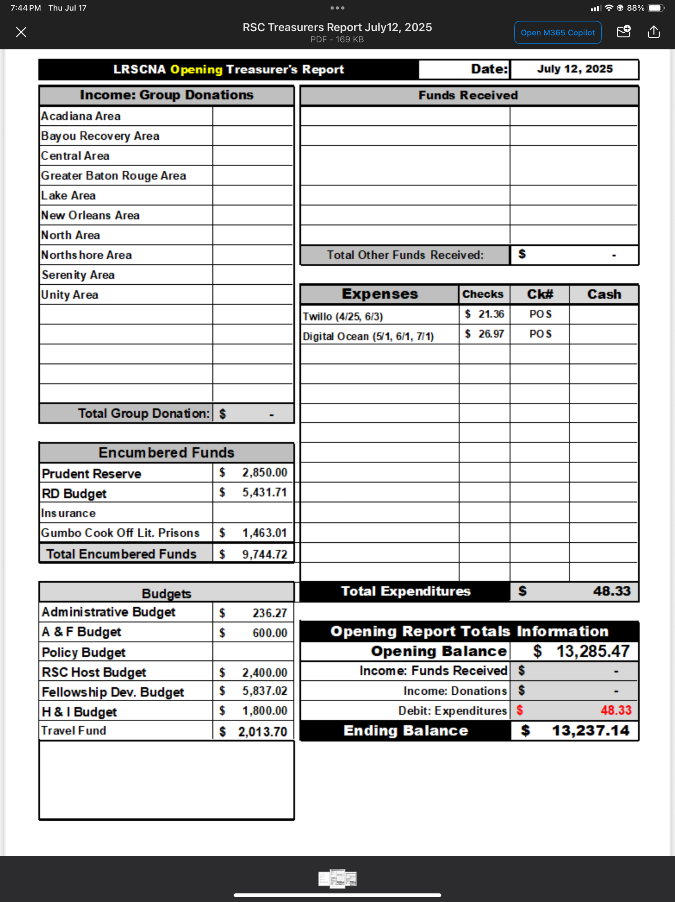
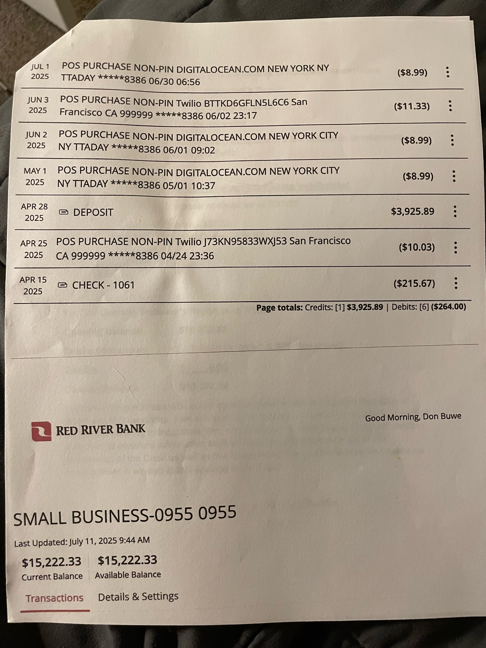
    - Secretary Report – Ashley J.
Good morning, everyone. Thank you for the opportunity to be of service to the Region.
ILS, Ashley J.

    - Regional Delegate Report – Bob St.
Regional Delegates Report for July 2025 RSC meeting

Hello all,

Got a couple of things to tell you about. First, we had a “Conference Participants” virtual meeting on April 26th .

- Anthony E, the Executive Director for NAWS, said that the losses from the WCNA were tabulated to have been $956,129.00. He reported that the issue of how to hold WCNA in the future is on the agenda for the World Board meeting scheduled for May. Asked about Tariff’s impact on our materials, he said “Too early to say... Primary impact is on plastic and metal products... We will have an increase in literature prices proposed no matter what though.

- Proposed updates to the Guide to World Services were posted for review and comments by fellowship at NA.ORG/conference

- World Unity Day is planned for 9/6/25... Virtual conference with presentations by various Regions and Zones: www.na.org/annualevents

- July 12th will be “Dealing with Disruptive and Predatory Behavior IDT.

- Laura B for Human Relations Panel talked about RBZ (Region-Board-Zone) process for nominations.

- In the Q&A portion there were concerns about the Conference Agenda Report (CAR) survey being repurposed to what is now a survey for literature projects and this being confusing to the fellowship. There were also some concerns about the time line for the CAR survey not allowing enough time for review by the fellowship. Questions about a low cost basic text, maybe just the 1st part of it without stories... Anthony reported that when 6th edition was adopted, group conscience at WSC was not to do this, and that has to be followed until or unless the fellowship says otherwise.

On April 28th the Financial Update came out and I posted it on GroupMe for everyone. If you didn’t see it or want a copy sent directly to you, let Scotty know and I’m sure he can get it to you.

We had another Conference Participants meeting on June 21st.

- Anthony E, Executive Director for NAWS said we will get a 90 day notice of increases in literature prices before they take effect. He warned that no orders would be filled from June 23rd to the 30th while they conducted a physical inventory of everything. So, if you had an order that got delayed during that time frame, now you know why!

- Jack H, WB Vice Chair, reported that the WB met in May and while they are discussion what to do with structure/format of WCNA they have nothing to announce just yet. He noted that 2028 will be 75th Anniversary for NA.

- It was announced that Becky M will be the new Executive Director for NAWS on retirement of Anthony E (5-year-contract).

- Some discussion about travel and lodging for WSC 2026 which will be 5/3-5/9/2026. There will be a form to fill out for Conference Participants requesting to be funded by World vs. those being funded by their service body. All reservations are being made through World though and the cost is said to be $234 per night with tax. (That’s arriving no later than the 2nd, and leaving on 10th. So 8 nights x 234 = $1,872 for lodging).

- Draft motions for next WSC must be in by July 1st and they must be in final form by August 3rd.

- The membership survey results will be published soon, but some numbers are: NA is 44% women, 55% male, 1% others. Including Iran, female membership dropped to 39%... 57% attend virtual meetings. 87% have a sponsor... 10% came to NA on MAT... Number still on MAT 4%... but 50% did not respond.

- Again announced that there will be a webinar on July 12 going over the Issue Discussion Topic material on Disruptive/Predatory behavior, open to all NA members.

- Laura B, Human Relations Panel (HRP), announced that at 2026 WSC there will be 10 WB seats open, 3 HRP seats open, and 1 WSC Co-Facilitator seat open. Deadline for Region-Board-Zone nominee submissions is 9/30/25.

Conference Agenda Report (CAR) Survey:

After somewhere around 500 “issues” or ideas for literature were submitted for consideration, the WB lumped what they thought were similar proposals into like categories. Conference Participants were then asked to vote for 5 of the issues as being the most important to address in this conference cycle. In this way, the issues are being prioritized for the top vote getters to be included in the final CAR.

I posted the raw material (issues/ideas) for you to review on GroupMe, but we had to respond by Sunday, 7/6, so there was no time to gather input from you, the ASRs, directly. So here are the choices I made and some rationale for them:

In the “New Recovery Literature” category, I don’t think World should be deciding on the introduction for an individual group. So none of those proposals were chosen. I also think that old-timers are much less likely to use and benefit from new literature, so I did not choose any literature ideas aimed at that group. I haven’t heard any complaints about the step-working guide, so I did not choose any of those issues. I’ve seen the DRT/MAT issue and whether those folks qualify for service and such as an issue in our Region so that was one of my choices. I also see “Ideas and Experience of Spirituality” as an issue in our Region so I chose that one. I see New Members / Early Recovery as vital to the growth of the fellowship in our region so that was my 3rd choice. Youth in Recovery was my 4th choice, and Recovery behind bars was my last choice.

In Category 2: Revisions to Existing Recovery Literature, while I agree with gender neutral language, I don’t think revising existing literature for that purpose is more important than updating/revising content. So, my choices were: Replace references to God with Higher Power... Revise Tradition 11 to include social media... Update “In times of Illness,”.... Update “Mental health,” .... and update Behind the Walls.

For the “New Service Material” category: I chose - Virtual Service... Fellowship Development... Social media.... Tools for managing electronic funds... and PR tools for Treatment.
In the Revisions to Existing Service Material, there were only 9 possibilities, and I chose: Guide to Local Service... H&I Handbook... PR Handbook... Disruptive and Violent Behavior... and Social Media.
For the category of Issue Discussion Topics, I chose: Use of funds, fund flow and fundraising... social media... Helping addicts find us... Spiritual v Religion... and Tradition 3 and membership/abstinence.

Now, I know that everyone will not agree on the choices I made for our Region, and I’ll tell you, I was not happy about being in the position of having to make those choices without more direct input from you. But this was the position I was in and I made choices that I thought best reflected the thoughts and feelings of our Region. I apologize for whatever degree of difference there is between the choices I made and the choices each ASR would have wanted me to make. The silver lining is that there are about 150 others that are making choices and the end result will still need to be voted on by you prior to the next WSC.

I think that’s all I have to tell you about. I’ll leave Southern Zonal Forum issues for Scotty to tell you about since he will be representing us there this month.

I do want to bring up one other thing though. I don’t recall what our practice as a region has been regarding funding of the RD, RD-alt, and RD-alt-elect to the WSC, and we, the RD team, need some clarification on that. In the very near future World will be sending us a form asking about this as well as for specific information on what reservations to make for us.

In loving service

Bob S, RD

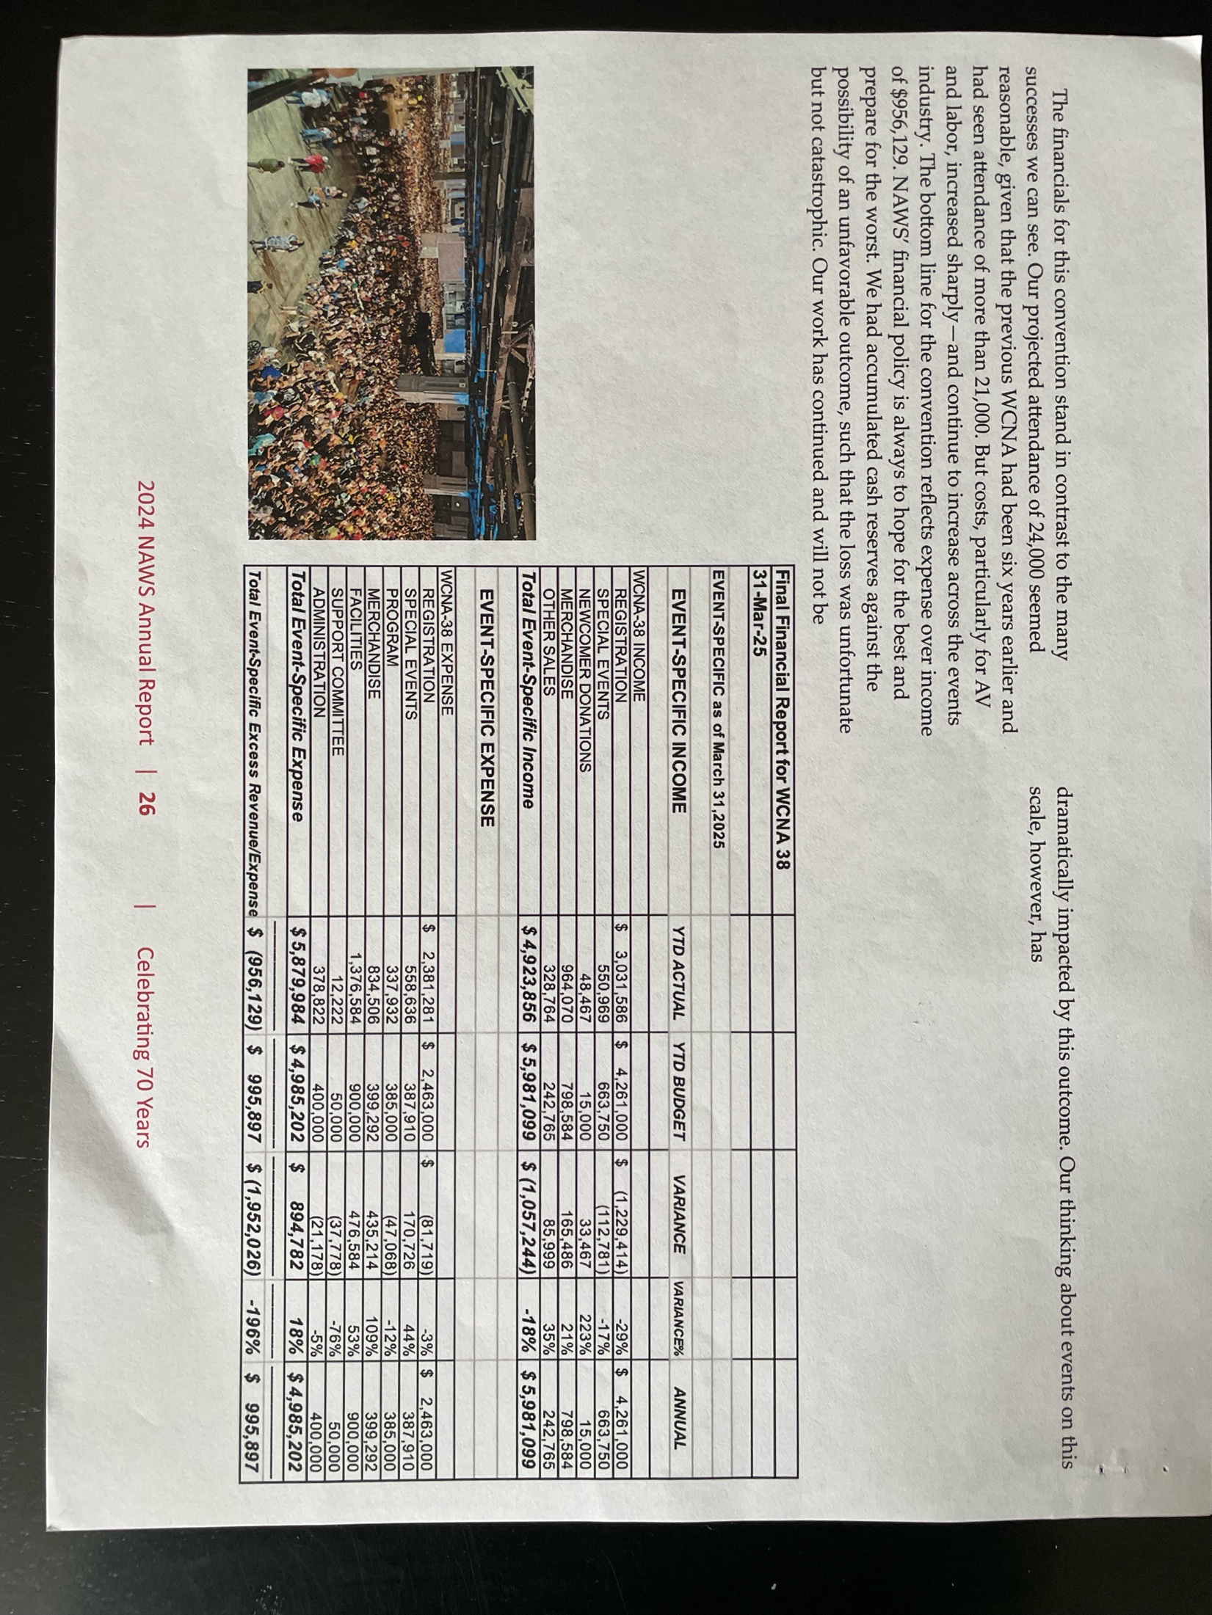
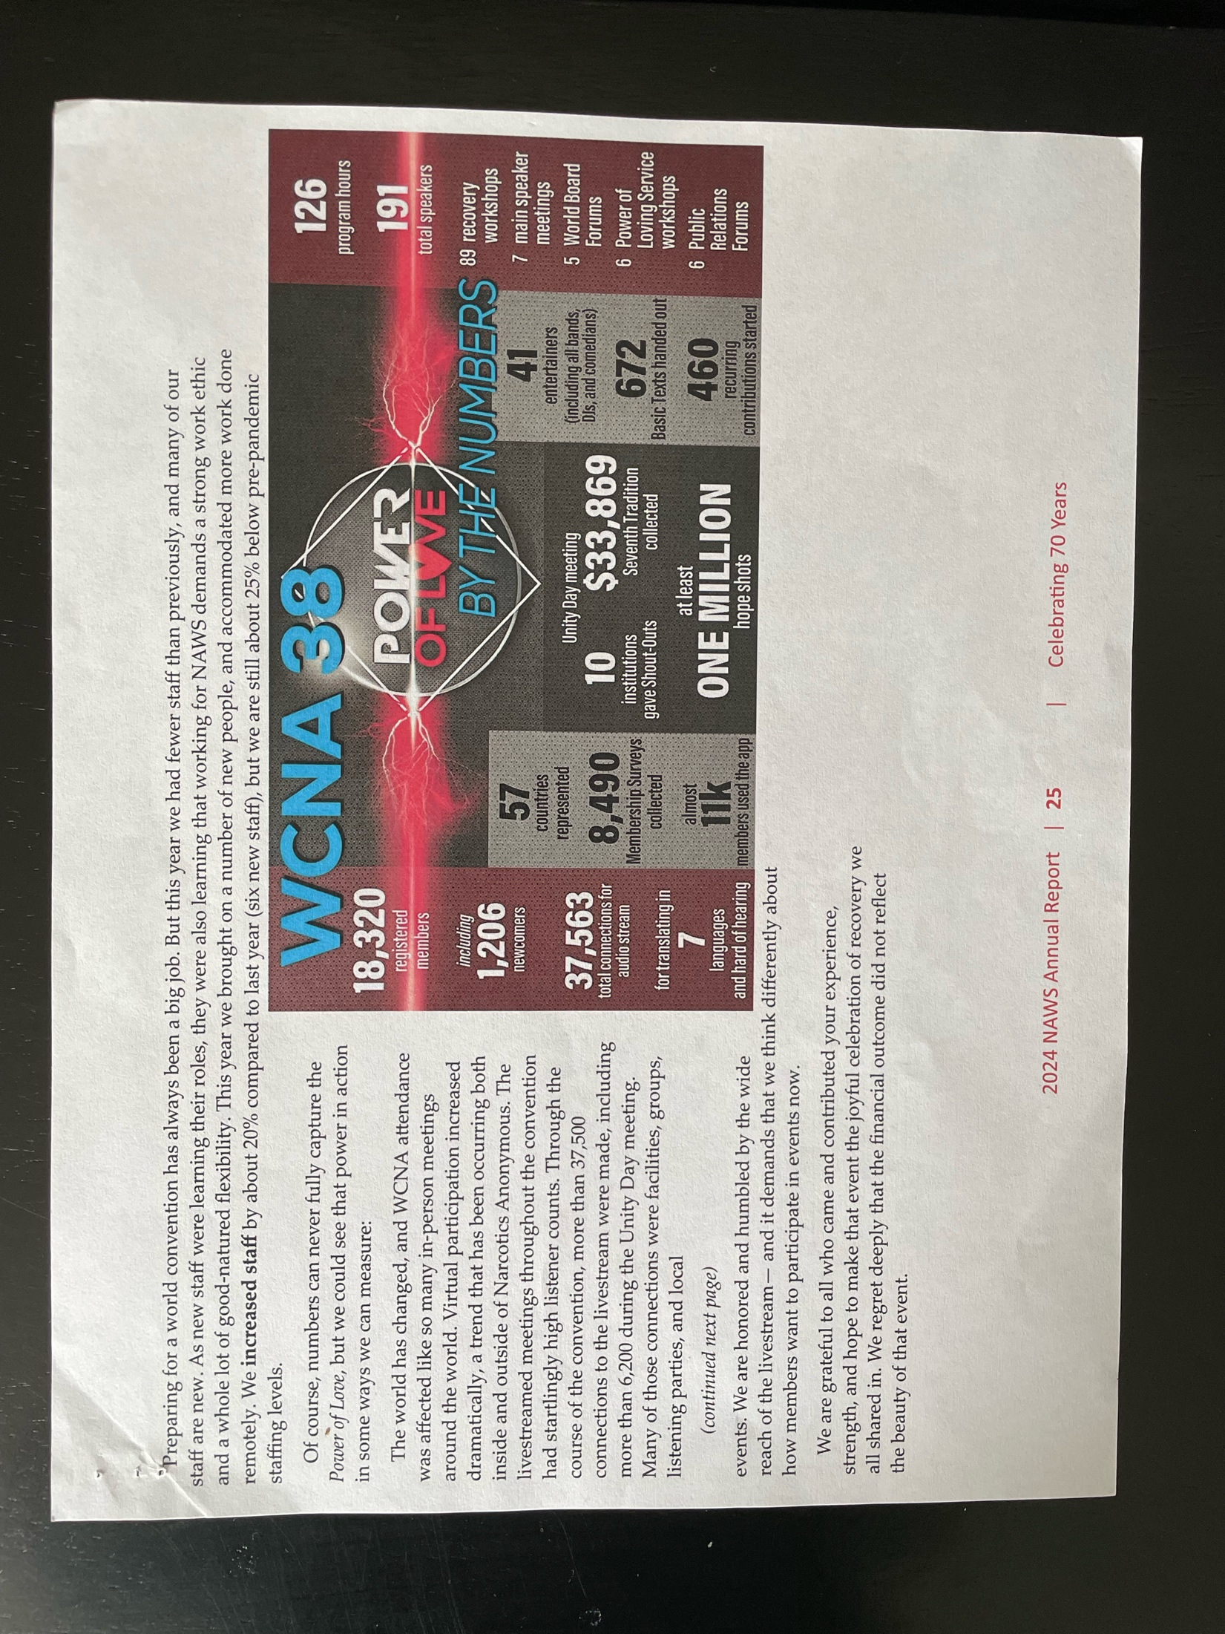

  - Standing Committee Reports:

    - Activities & Fundraisers – Vacant – Amy G

Good afternoon, A&F is currently working on the Gumbo Cook-off. Still trying to decide on a date. Last Region we said September 6th or 13th, but both of those are LSU away games. Ron checked with the facility, and it is available for the 6th, but I also have him checking into September 27th because that is a by week. I hope to have some kind of flyer before the end of the weekend. Also, I would like to ask Unity, N.O., and Northshore to being talking to your Areas about upcoming events that y’all normally do. Pre-Christmas & Mardi Gras Fundraising time will be here before we know it. N.O. Has flyers out for a Convention Halloween Fundraiser. I would like to thank everyone for posting your flyers on the GroupMe & LARNA FB group and other to get the word out.

In Loving Service,
Amy G.

    - Hospitals & Institutions – Stephen L.

H+I Report 07/13/2025

In H+I, the Areas of the Region combine to fulfill the responsibilities of 28
commitments. I will be passing around a list of Areas and their commitments.
Please update any outdated information. Since the last Region, more work has been
done regarding putting together an H+I commitment at Angola. Members in
surrounding Areas have expressed an interest in participating. The ability to cover
the DOC part of the orientation online is helpful. An H+I Learning day will be
taking place on July 19th in Baton Rouge that will include a step-by-step guide of
the Angola regulations. If interested in participating, I would highly suggest
attending. If we’re going to be able to back up a commitment there, it is going to
take multiple Areas participating. An attainable goal is a once-a-month commitment
with rotating members covering it. If interested in receiving the link to the
orientation website, contact me at any time. Another Learning Day will be taking
place on August 9th in New Orleans. I’ve been really encouraged by the amount of
interest that’s been shown in helping to spread H+I. I am available to help any Area
interested in putting one together. Literature wise, I have some Basic Texts
available this weekend for jails/institutions commitments. I will also be making an
order for the next Region.

In Loving Service,
Stephen L.

    - Fellowship Development – Richard T.
Fellowship Development July 2025 RSC
Hello All!

Fellowship Development has been active in the last quarter. We now have a new group in Rayville
which meets on Mondays and Fridays. I have visited with them several times and making sure
they have the support they need to get going. Great group of people up there and it looks really
promising. There are four rehabs in Rayville and we hope to start getting H&I meetings in them
soon. New Life group in Monroe is now meeting four times a week so between them and Rayville
there are now six meetings a week either in Monroe or within twenty minutes of Monroe.
Serenity Area had a function on June 21st in Monroe. This was basically a Fellowship Development
event to bring awareness to the recovery community in Monroe that NA is alive and growing in
Monroe. Aaron D from Monroe and Floyd G from Shreveport were the speakers. We had approx.
75 in attendance and everything went great. In addition to addicts we had several councilors
from rehabs in attendance that requested NA material and were excited we were there.
I’ve been in working with the groups in Natchitoches and they are doing well. They have an NA
Conference coming up on July 26th. I will be one of the speakers and most of the other speakers
will be from around the region. I’m attaching a flyer with this report. While they are not currently
part of LA Region we are working much closer with them than in the past and have a much closer
relationship. I’m hopeful that they will affiliate with us in the future. Their meetings are now
listed on the Central Area meeting list so their meetings are much more visible and accessible.
Jared L is producing four videos targeted for TikTok and Instagram that should be available by the
end of July or early August. The cost is $3000.00 total and is part of the approved 2025 Fellowship
Development budget. Most of the social media budget for 2025 has been reserved for getting
these PSA vides out there when they become available, I also ran a 30 day Facebook campaign
targeting a 18 to 45 audience and have the results attached to this report.
To my knowledge the larna.org problems either are fixed or in process of being fixed. The Area
websites that I admin are all up and running and I’m still slowly upgrading the backends to current
operating system releases. The Region Helpline is working fine and I hope to do a major update
on it by the end of the year that will fix the reporting and some other minor glitches.
I don’t have a budget for 2026 but will have it at October RSC. I hope to have one or more
fellowship development subcommittee meeting between now and then to get this together.
ILS
Richard T
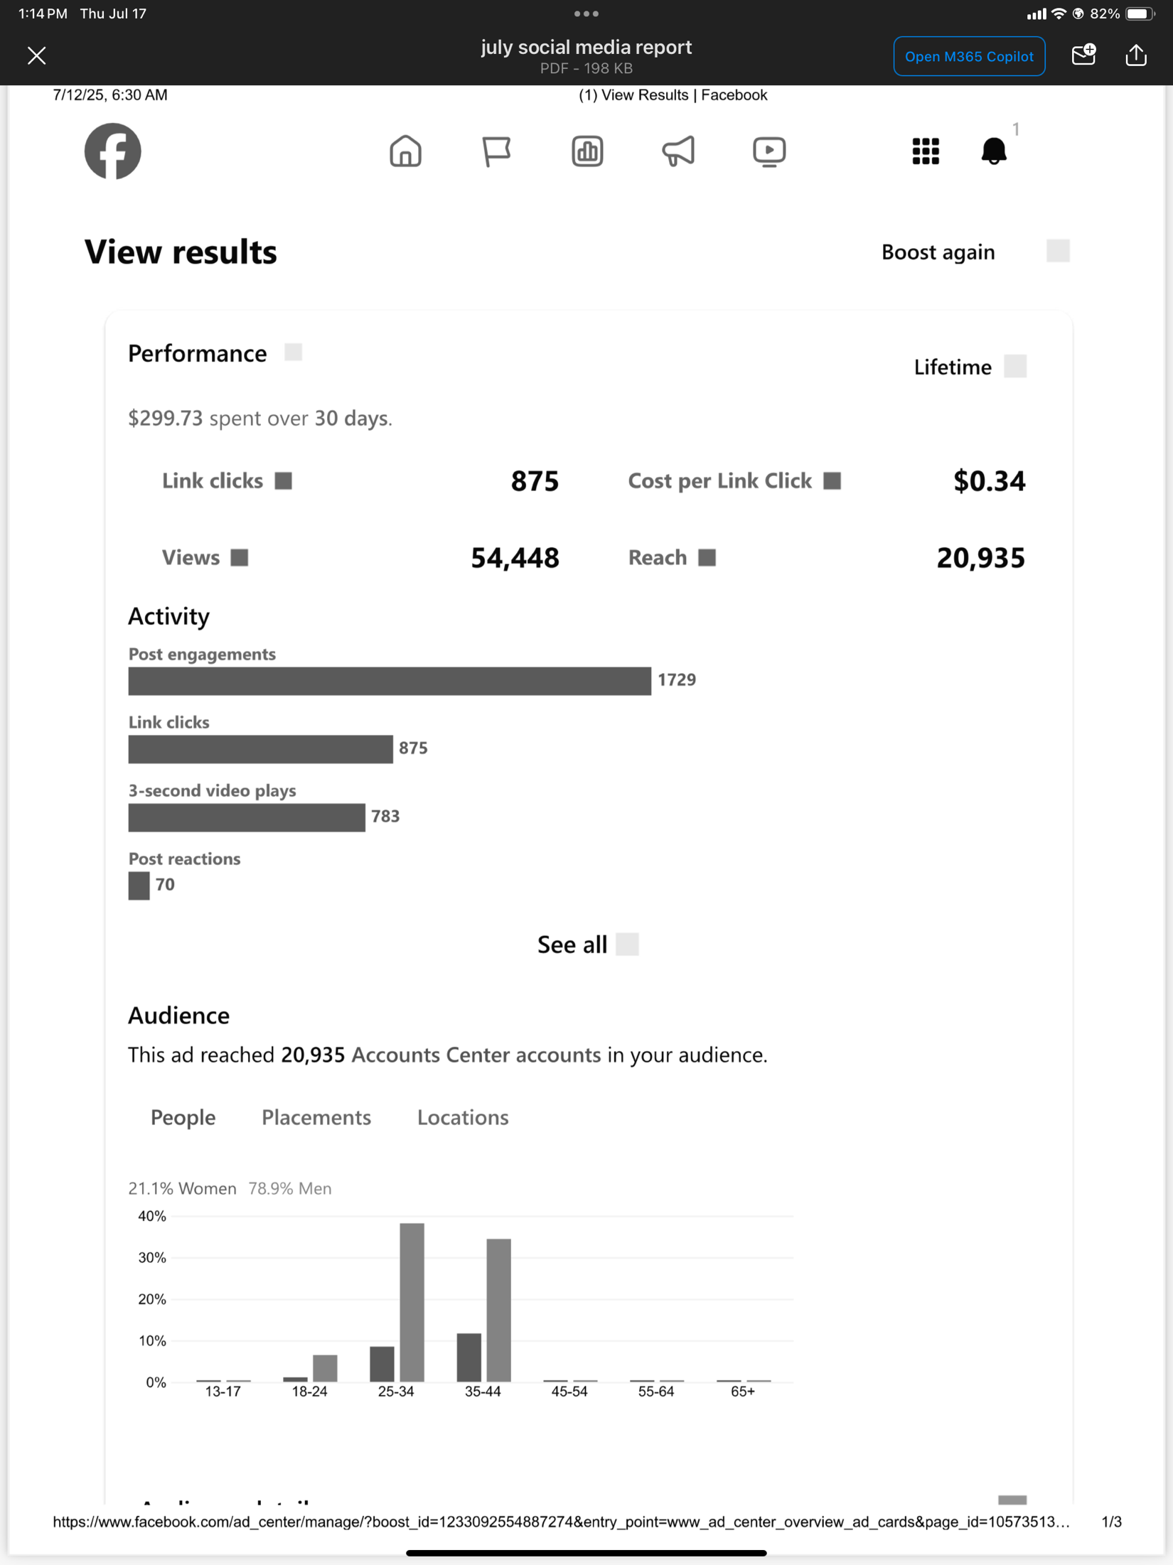

    - Policy – Doug F.
POLICY REPORT
JULY 12, 2025
My name is Doug and I'm an addict.
We passed out new guidelines to everybody and discussed them. Passed around sheet to put area policy chairs on. Nobody wanted to hold any position for this committee. I will continue to update policy as times go on. More will be revealed in this committee as time goes on.

IN LOVING SERVICE,
DOUG

  - Interested Parties:

    - Board of Directors –
BOD report to July region
Greetings all sorry I won't be able to attend region. It's my wife's birthday and we always go somewhere for it. It was an honor to serve on the board of directors. I have faith in all the people on the board. Pixie is your new board. Chair and Steven is vice Ric S has remained as treasure. Billy is going to be secretary. Denise will be rolling off the board in October so there will be 2 open positions on the board of directors. I would like to thank Steven for filling end for me.
He should be able to answer any questions you might have. We will postpone the donation to region. Since the next convention will be in New Orleans, we have to redo the budgets for them. It will be at the doubletree Don B is chair Stephen H vice chair secretary is Seven R hotel liaison. Is Kaycee C registration Claire b programming Patty? Merchandise, Aubrey, and I'm sure they will fill the rest of the positions. They are selling raffle tickets for $20.That includes 2 room nights.2night's parking and 2 registrations. Last year's convention had low attendance and made a
profit around $8000. Steve is revamping the website and we're looking into buying a plug in to sell raffle tickets on it. I have faith in this convention committee and think they will do a great job. There will be a fundraiser October 31st. Halloween party I believe Don has flyers. Thank you for letting me serve on the BOD. It was a wonderful experience.

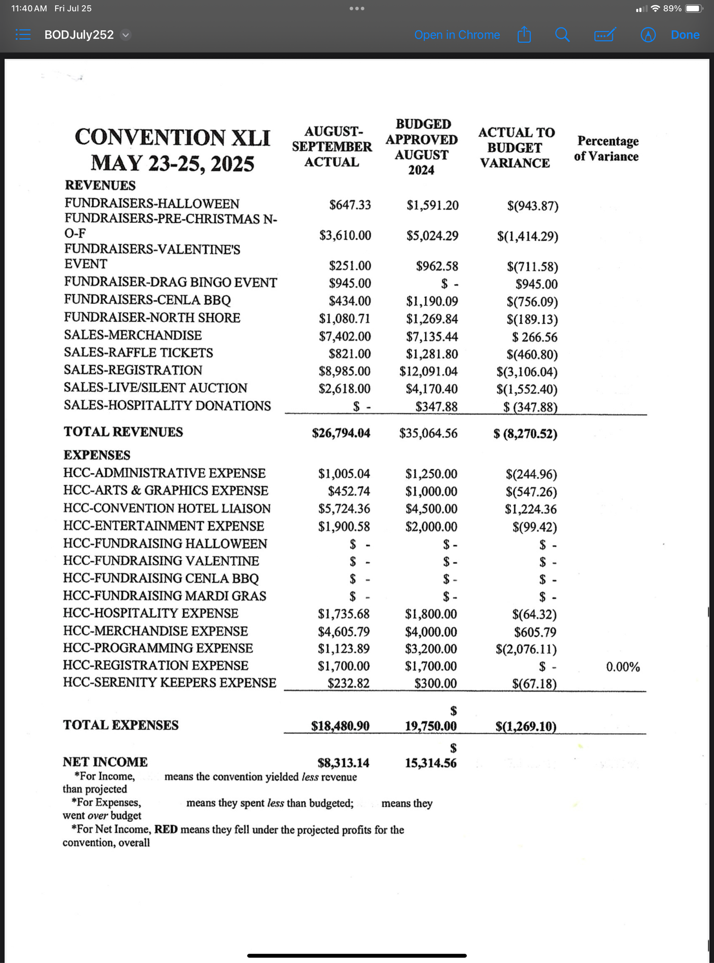
LRCC Financial Report for Louisiana Region - July 12-13, 2025

Final Financial Statement for Convention XLI held May 23-25, 2025. The Financial Statement is
attached. In summary, the convention met neither the projected income, nor the projected profit,
however, they did net $8,313.14. The original seed money was transferred back to the LRCC main account on 6/20/25, leaving the net profit-or surplus as regards 501(c)(3) organizations in the HCC account. The board will need to decide today how much, if any, should be sent to Louisiana Region as a donation. It is suggested that additional funding be retained in the LRCC main account since we do not yet know fully how to plan for Convention XLII which will be held in New Orleans May 22-24, 2026.
HCC-2026 Bank Account. Our third account, which had an opening balance of $500.00 has been
set for use by the HCC for next year. Because that HCC does not currently have a treasurer, it was
suggested at the end of the 2025 convention that the LRCC Treasurer will maintain those records
until such time as a competent individual can be seated by the HCC. With deposits from Early
Bird Registration and Raffle Ticket sales, as well as the expense for the Charitable Gaming license, the balance in that account is $1,748.26. The LRCC board needs to develop a budget before fully funding this account.

  - Area Service Representatives Reports:

    - Acadiana Area – Anthony L.
We have Updated the website with meetings that are back meeting in person again to the best of my knowledge. See our website for more info. On the meeting list. Aascna.org
Acadiana Area Service Committee of NA: Host meetings seven days a week! We have 5 active N.A. groups and 2 inactive, with a total of 32 meetings! We have 3 H&I commitments, Tyler Mental Health, Victory Treatment Center, and Sheriff Rehab Program. H&I is working on getting more members to commit to going to the Woodlake Treatment Center in Abbeville, LA. H&I learning day will be TBA at Acadiana Cares in Lafayette, LA 12 PM until! Acadiana Area of NA has a donation of $300.00.
In Loving Service,
Anthony L.

    - Bayou Recovery Area – Taylor P. – Report Submitted
Hello NA Family from the Bayou Recovery Area ASR
We had 8 Groups represented at our last ASC meeting, which is double the number for our quorum requirement. We still do not have GSRs showing up to represent all of the Groups in our Area. We have 27 NA Meetings on our meeting list and that includes two Zoom meetings. Our Groups, with a few exceptions, are having a lack of NA members attending and many with open Service Positions.
We currently have the open ASC service positions of Vice Chair, ASR Alternate, Activities Chair, Policy Chair, H&I Chair, and Public Relations Chair.
We still have no donation to RSC due to low contribution amounts from our Groups. We haven’t even met the budget amounts for our subcommittees.
We have a nomination for RDA Elect from our Area.
Our next Bayou Recovery ASC Meeting is on Sunday, July 27th, 2025.

From Bayou Recovery Area Subcommittees:
OUTREACH- Ric S.
· Delivered a brochure rack with meeting lists and an assortment of pamphlets to Avenues Treatment Center. Since our panel is there every two weeks, we are checking to be sure it is well stocked each time.
· Blake from O’Brien House has requested any literature we can provide. I explained that there isn’t a budget at any level of NA that can support giving the Basic Text to folks who are, for the most part, transient and undecided about a long-term recovery program but we can provide a small brochure rack, which will be delivered soon.

· Dedicated Concepts, 6220 Florida Boulevard, Suite C, also requested literature. I have the same set up to deliver to them but have not been able to get anyone to return my calls.

· We have determined that the meeting on Amite Church Road in Denham Springs is not only sporadic but also seems to be a conglomeration of 12-step programs and perhaps even the occasional speaking in tongues. To preserve the integrity of Bayou Recovery Area and the NA fellowship as a whole, we have removed that meeting from the list. Again. If we learn later on that there is a stable NA home group, we can visit the meetings a few times to see about adding them to the meeting list.

HOSPITALS AND INSTITUTIONS – Ric S.
“MOVING H&I PANEL - While there’s not much new to report, our panel is still participating in bi-weekly meetings at Avenues on Monday nights. They’re still experiencing some growing pains because it’s not very organized over there. Their individualized care plan to deal with each resident individually probably works well in one-on-one settings but the lackadaisical attitude with residents and even with techs cause distractions when we are presenting our panel at the meetings. I have sent a message to administration asking for a little more structure but have not heard back from Misty yet. We’d like to fill the July and August calendars at today’s meeting so please give your commitment today.

· STOA - We regularly get contacted by Crystal Flowers from STOA, also on Florida Boulevard at 11188 Florida Boulevard about a regular meeting. Until we get more volunteers, we cannot commit. We can, however, attempt to schedule folks for that facility every other Monday, opposite the meeting at Avenues, but only if we get more volunteers. We tried to meet Thursday, July 10th, but could not raise a panel. We will try again on Thursday, July 17th.

· PRISONS-In conjunction with Stephen L from Region, we have scheduled H&I Orientation and Training Day here in Baton Rouge for Saturday, July 19, from 5:30 until 7PM, immediately followed by the Saturday Night Live meeting. This meeting will include a light meal, probably pizza and drinks, which are the easiest. The estimate for the pizza is $70. Flyers are available today and digital copies have been distributed as well. Please take some flyers to your home group, or to meetings throughout the region. Anyone wishing to go to DCI or LCIW should attend as well. It’s very important to be sure everyone knows you must complete the training and online video, after which your certificate and background check documents must be collected and submitted as part of the group. No one can participate unless previously approved by the Office of Public Safety. Also, certification must be renewed every year on your anniversary date.

· Diane M from the Keep it Simple group in New Roads is asking for support to visit the prison in Pointe Coupee Parish and/or to provide literature when possible. Again, we need lots more volunteers before we can take on another project so hopefully others can step up.

· PUBLIC RELATIONS – Ric S.
We were going to report that I have made many attempts at follow-up with Cheryl Wyatt at East Baton Rouge Recovery Court but got no response. Oddly enough, as I prepared this report Friday morning, I received an email from Cheryl stating they will try to get us on their schedule soon. Cheryl also included Treatment Director, Ilisha Lucas to keep her in the loop. Hopefully we can bring a team back to the courthouse in the next few weeks so please step up if this is something you can do.

We have new information: We currently have an appt. to go to EBR Parish Recovery Court (formerly Drug Court) on Friday the 18th of July.

· Summer is typically slow regarding NA meeting attendance so we hope folks can provide support to struggling home Groups so they don’t have to close. This time last year, we had 34 meetings on the list for the Bayou Recovery Area. At present, we have 27 meetings listed. Two groups that suffer the most from dangerously low attendance and virtually no donations include: R U Ready, the Wednesday night meeting at 7 PM on Mollylea Dr, Vision of Hope, Tuesdays at 7:30 pm in Zachary, Keep it Simple, Sundays at 3PM in New Roads and most likely others. Of course, each group was encouraged to attend the monthly Area meetings to remain involved in the NA cause.

ILS, For the Bayou Recovery Area, ASR- Taylor P.

    - Central Area – Pam G.

Hello Everyone,
My name is Pam and I’m an addict. I am the new ASR for the Central Louisiana area.
We currently have two meeting facilities in our area, Rivercity Clubhouse and Champion Recovery. Rivercity has four meetings a week and Champion has five meetings a week. Attendance has been significantly decreased over the last few years. We have had some discussion about starting an NA meeting at one of our facilities on Saturday nights. More will be revealed about this at next Region.
H & I has been doing well. We are currently sharing the message at three facilities and are encouraging new members to join.
Fellowship & development- We currently have one radio station in Alexandria playing NA’s public service announcements.

Activities recently had a crawfish boil for a convention fund raiser and it was very successful. On July 4th we had an event to try and help our areas unity. Unfortunately, we actually lost money on it due to lack of participation.
Unfortunately, we do not have a donation to Region today due to low attendance and decreasing basket money.
Thank you for allowing me to be of service.
Sincerely,
Pamelyn G.

    - Greater Baton Rouge Area – Sherina J
No Report Submitted

    - Lake Area – Julian B.
Lake Area ASR Report July 12th, 2025
The Lake Area, as of right now, has 4 groups and holds 36 meetings every week. All groups hold birthday and speaker meetings regularly. Our area schedule is up to date online. As far as H+I, we currently have 3 commitments and another commitment to be added this week. Odyssey every Sunday, women at CCC on Tuesdays, men at CCC on Thursdays and we will begin going to Steps on Wednesday. The Steps facility is also adding a regular NA meeting on Sunday. More details to come. In events, The Recovery Group hosted its first annual canoe trip for the Lake Area. The turnout was great, and it was a lot of fun. Also, Spirit of the Bayou hosted a Unity Day cookout with a wonderful speaker. In upcoming events, the Agape group is having its anniversary on July 17th – July 20th. The Lake City Freedom group is currently planning their anniversary. The Lake Area will also hold its annual convention fundraiser Halloween Bash. Dates and times for that are TBA. We will distribute information and flyers as details develop. Our 7th Tradition is $100.
In Loving Service, Julian B.

    - New Orleans Area – Don B.

Hi, my name is Don, and I am an addict.
Meetings are conducted daily and comprise 42 in-person meetings, 2 hybrid meetings, and 30 virtual meetings.
The New Orleans Area Convention is forthcoming and will be held at the Hyatt Riverside Hotel from July 24th to July 27th. Registration and ticket purchases are available online at NOACNA.com. Room rates and event fees are as follows:
• Registration: $35.00
• Comedian Show: $25.00
• Fashion Show: $25.00
• Banquet: $60.00
• Room Rate: $159.00
The Hospitals & Institutions (H&I) committee will hold a Learning Day on Saturday, August 9, 2025, at 2:00 pm at St. Paul Lutheran Church, 2624 Burgundy St., New Orleans, LA 70117. The Regional H&I Chairperson has accepted an invitation to serve as a guest speaker. The committee allocated $2,200.00 for literature, which was distributed among five treatment center commitments, and acquired 25 H&I Handbooks for Learning Day participants.
Currently, there are five H&I commitments at the following treatment centers:
• Bridge House – Every other Monday, 7:00 pm
• Grace House – Thursdays, 7:00 pm
• Integrity House – Thursdays, 7:00 pm
• Odyssey House – Fridays, 7:00 pm
• Odyssey House – Saturdays, 7:00 pm
Additional female panel members are requested.
Open Mind will host a Halloween Night Regional Convention Fundraiser on Friday, October 31, 2025, at 583 Broadway St., New Orleans, LA 70118. A suggested donation of $15.00 will be accepted; however, no addict will be turned away. The event will feature food, speakers, fellowship, a DJ, a 50/50 raffle, an auction, and a costume contest.
The Public Relations team organized a phone line training day and led a poster campaign during Narcotics Anonymous PR Week in June. A Public Relations Presentation for professionals and others who interact with individuals facing addiction is planned for later this year, with the date and time to be announced. Posters, stickers, and PR business cards featuring a QR code for the New Orleans Metro Meeting list have been distributed citywide. These cards display the New Orleans Area helpline on one side and the Regional Helpline on the reverse.
There was no 7th Tradition donation from the New Orleans Area for this quarter.
The Louisiana Regional Convention Host Committee is diligently preparing for this year’s convention, themed "Desire: The Road Starts Here." Pre-registration is $35.00 until December 31, 2025, after which registration will increase to $45.00. The Host Hotel will be the Doubletree New Orleans, 300 Canal St. Our first Convention Fundraiser is a “Hotel Convention Package” Raffle, valued at $500.00. Tickets are $20.00 each. Drawing will be New Years Eve. Winner need not be present. The winner will receive two complimentary nights at the Doubletree Hotel, two nights of valet parking, and two registrations for this year’s convention. For ticket purchases, please contact me or Steven H. Those interested in selling tickets should consult Steven H. regarding eligibility under Board of Directors guidelines. Areas or Homegroups interested in hosting a fundraiser for this year's convention should contact Steven H., Vice Chair. If anyone is interested in joining a subcommittee please contact our chair or vice chair.
Don B. – Chair – 504-234-8301 donb.larna@gmail.com
Steven H. – Vice Chair – 504-377-7491 shernandez2674@gmail.com
In Loving Service,
Don B.

    - North Area – Ashley J.
Hello Family,
North Area is doing great. There are currently 5 home groups in the North Area with 14 meetings a week. We have new meetings Thursday nights at 6:30 at RiverPark Church in Shreveport, and Monday through Friday at noon. One of our home groups closed their Friday 7:00PM meeting. There are 30-40 addicts in attendance per meeting and growing steadily. In May our ASR Alt. Stepped down, the position is still open. We also lost our Policy Chair last month; this position is still open as well.
Fellowship Development plans to take literature into several treatment centers, both inpatient and outpatient, as well as other facilities soon. We were having difficulty with our area website, but it was fixed recently. Our FD chair is going to continue to work with Richard to continue to grow our fellowship in the North Area.
H&l is going very well with Panels going into CADA on Tuesdays at 7 pm, Sundays at 5:45 pm and Uprising Addiction Center every other Saturday at 3:00 pm. We continue to get positive feedback from the facilities and their clients. The North Area is currently needing more H&I participants and panel leaders. We have been asked to carry meetings into other facilities and are currently unable to take on any other commitments due to the lack of participation.
We will be having a World Unity Day Function Saturday September 6th 11AM to 5PM. I will post the flyer to the Regional Website and to our Group Me as soon as it is available.
Our next ASC meeting will be next Sunday, July 20th at 1:00 PM at 1321 Airline Drive in Bossier City. Donation to Region $200.00.

ILS,
Ashley J.
    - Northshore Area – Charles W.
No Report Submitted

    - Serenity Area – Daniel S
Hello y'all. The Serenity Area is doing well. We currently have 15 weekly meetings spread out between Farmerville, Haynesville, Homer, Minden, Ruston, Springhill, Monroe, and Rayville. We added 2 new meetings in Rayville La since the last Region meeting. They meet at 413 Francis St Rayville, La 71269. They meet on Monday and Friday at 7:30 pm. For more information about our meetings see our website at serenityna.org.
We have no new business from our Area. We continue to take meetings into 2 treatment centers. One located in Ruston, La and one located in Homer, La. We set up the literature racks provided by y'all here thru H&I in a couple treatment centers we don't have to human power to actually take meetings inside. One is at Freedom Recovery in Monroe, La and the other is at Laark in Marion, La.
We don't currently have any activities planned at this time. We do have a Region Donation of $100.

In loving service
Daniel S

    - Unity Area – Vacant -
We have minimal changes from my last report.
1. Our 12 noon meeting on Sunday has folded due to lack of support.

2.Our H+I committee commitments remain the same.

3. Our PI committee attended a meeting with the Jefferson Parish Diversion Staff. We left
meeting lists and literature with them for their clients. They were happy to have us there.

4. Our A+F committee have no functions planned.

5. We are having elections in July and hope to have an ASR at next RSC.

In Service,
Robbie G

- Nominations and Election:
  - Board of Directors: -

RSC Nominations: (Resumes attached to end of Minutes) Voting will be at RSC in October.
    - Chairperson – Amy G
    - Vice Chairperson – Daniel S.
    - Treasurer - Don B.
    - Secretary – Ashley J
    - Regional Delegate - Bob St.
    - Regional Delegate Alt. – Scotty H
    - Regional Delegate Alt. Elect –Taylor P
    - Activities & Fundraisers – Open
    - Hospitals & Institutions – Open
    - Fellowship Development – Richard T
    - Policy – Doug F.
*** All positions are still open for nominations we can have multiple nominations for any position.
*** All Nominee must be present at the October RSC in Northshore Area In person or via speaker phone.
*** All Nominees must fill out a Service Resume Form. Please contact Don B. 504-234-8301 or donb.larna@gmail.com to get a copy.

- Old Business (Unfinished Business):

None
- New Business:

  - Motions:
    - Motion #2025-07-01
Maker – Don B Treasurer
2nd – Taylor P Bayou Recovery Area

Motion: To reimburse Don B for printing policy, buying paper for printer and envelopes
to mail donations. Three receipts: Walmart $13.69, Office Depot $31.81, Office Depot
$21.97, totaling 67.47
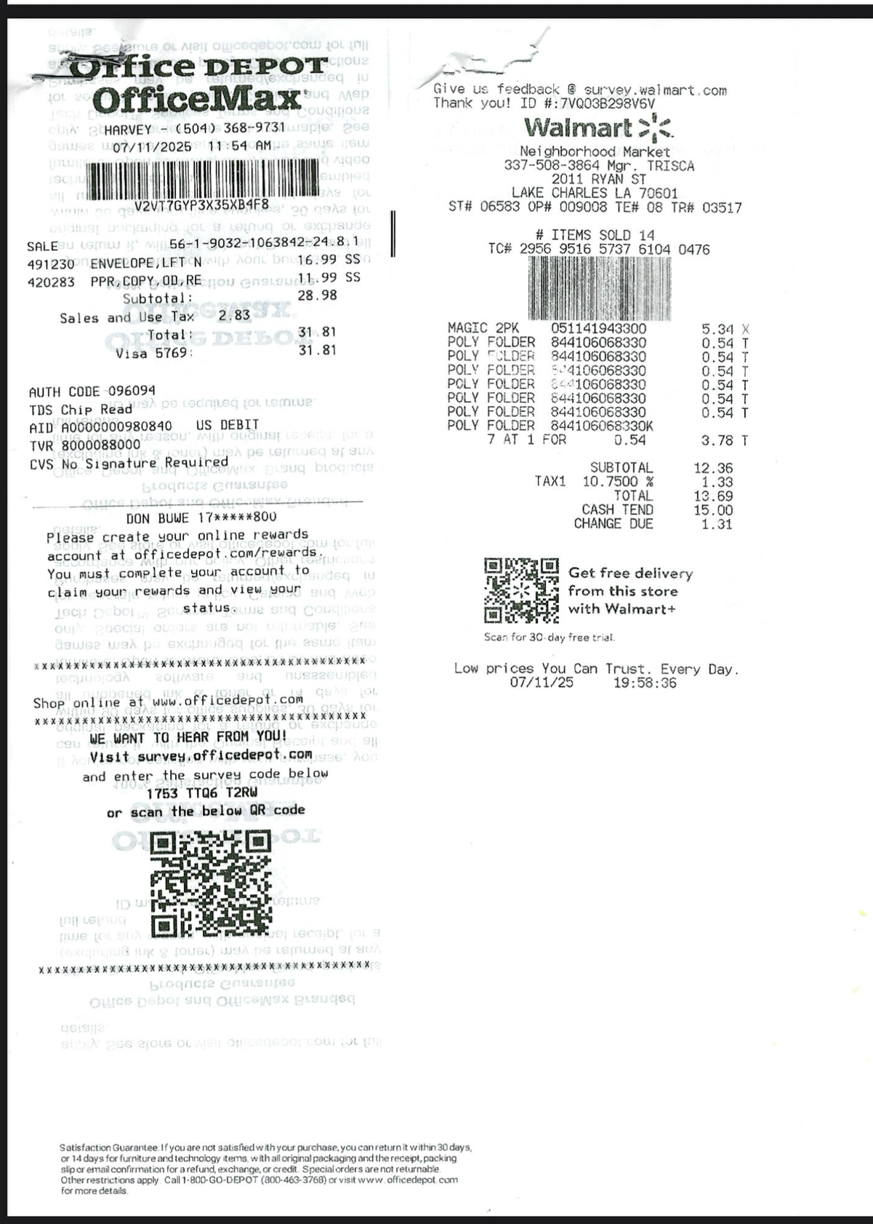
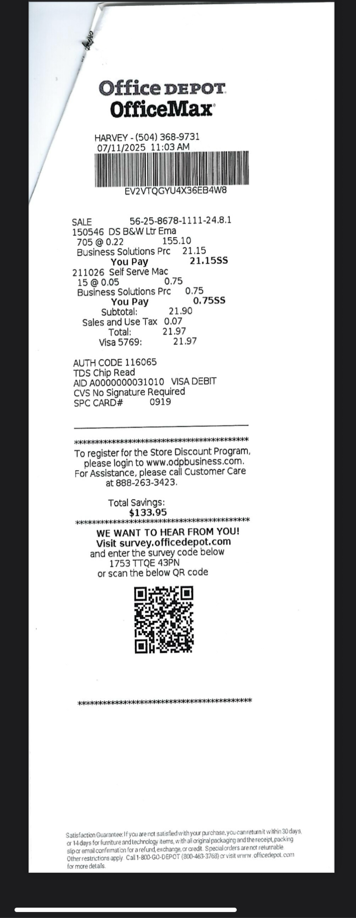
Intent: To be fully self-supporting

Call to Vote: For:6 Against:0 Abstentions: 1
Motion Passed

    - Motion #2025-07-02
Maker – Stephen L H&I
2nd – Pamelyn G Central Area

Motion: For the Region to take on a monthly H&I commitment at Angola State
Penitentiary.

Intent: To provide a source of coordination between Areas to help fulfill a difficult commitment that furthers the lengths of supporting our Primary Purpose.

Motion Referred Back to Areas

    - Motion #2025-07-03
Maker – Richard T Fellowship Development
2nd – Daniel S Serenity Area

Motion: To reimburse Richard T for payment to Facebook for $299.73

Intent: To be fully self-supporting

Call to Vote: For: 7 Against: 0 Abstentions: 0

Motion Passed

    - Motion #2025-07-04
Maker – Stephen L H&I
2nd – Ashley J North Area

Motion: Policy Change – To change #9 in Financial Guidelines (Page 21) from: “That a quarterly donation sent to the WSC will be determined at the end of LRSCNA, as long as the working balance of the Region remains above the Prudent Reserve. Currently 10% to WSC and 3% to SZF.”
To: “That a quarterly donation sent to the WSC will be determined at the end of LRSCNA. It will consist of unencumbered funds. Currently 10% to WSC and 3% To SZF.”

Intent: To practice fiscal responsibility.

Motion Referred back to Areas

    - Motion #2025-07-05
Maker – Anthony L Acadiana Area
2nd – Julian B Lake Area

Motion: Policy Change – To change the donation to World and SZF from the % of total funds to % of area donations every quarter.

Intent: To be financially responsible with Region funds

Motion Referred back to Areas

    - Motion #2025-07-06
Maker – Stephen L H&I
2nd – Julian B Lake Area

Motion: To reimburse the purchase of 25 Basic Texts for jails and institutions in the Region. Total $350.00

Intent: To utilize the Gumbo Cook-off funds for their stated purpose.

Call to Vote: For:7 Against: 0 Abstentions: 0
Motion Passed

    - Motion #2025-07-07 2/3 Majority
Maker – Doug F Policy
2nd – Pamelyn G Central Area

Motion: Policy Change: To change in Policy: Page 23, #5 to say: “Terms of service suggested that all positions in Region serve no more than two consecutive terms of office in the same position.

Intent: Rotation of service

Call to Vote: For: 6 Against: 0 Abstentions: 1

Motion Passed

    - Motion #2025-07-08
Maker – Don B New Orleans Area
2nd – Ashley J North Area

Motion: A. To vote on Motion #2025-07-08 on the floor

Call to Vote: For: 7 Against: 0 Abstentions: 0

Motion: B. To suspend donation to WSC and SZF.

Intent: To figure out our budget and wait for direction from the Areas.

Call to Vote: For: 7 Against: 0 Abstentions: 0

Motion Passed

    - Motion #2025-07-09
Maker – Daniel S Serenity Area
2nd – Ashley J North Area

Motion: To write a check to Amy G. for $300.00 seed money for the Gumbo Cook-off.

Intent: To spread NA in LA Prisons

Call to Vote: For: 7 Against: 0 Abstentions: 1

Motion Passed

    - Motion #2025-07-10 2/3 Majority
Maker – Don B Policy Ad Hoc
2nd – Trent H Northshore Area
Motion: Page 10 Add lines 10 and 11 to the general guidelines section.10 informs everyone that Saturday subcommittee meetings can be attended virtually and 11 gives permission for subcommittees and ad hoc committees to be able to use the virtual platform to hold meetings.
Intent: To inform members of the availability of virtual platform

Call to Vote: For:8 Against:1 Abstentions: 1
Motion Passed

  - Host Area For July 2024 RSC: Lake Area

We would like to Thank Lake Area for hosting Region this weekend. $2.00 was
turned in from the function Saturday night. No seed money was taken from the
Region for this function.
  - Host Area for October RSC:

Next Region will be held in the NorthShore Area on the 4th – 5th of October 2025

- Treasurer’s Report – Don B. - Closing Treasury Report
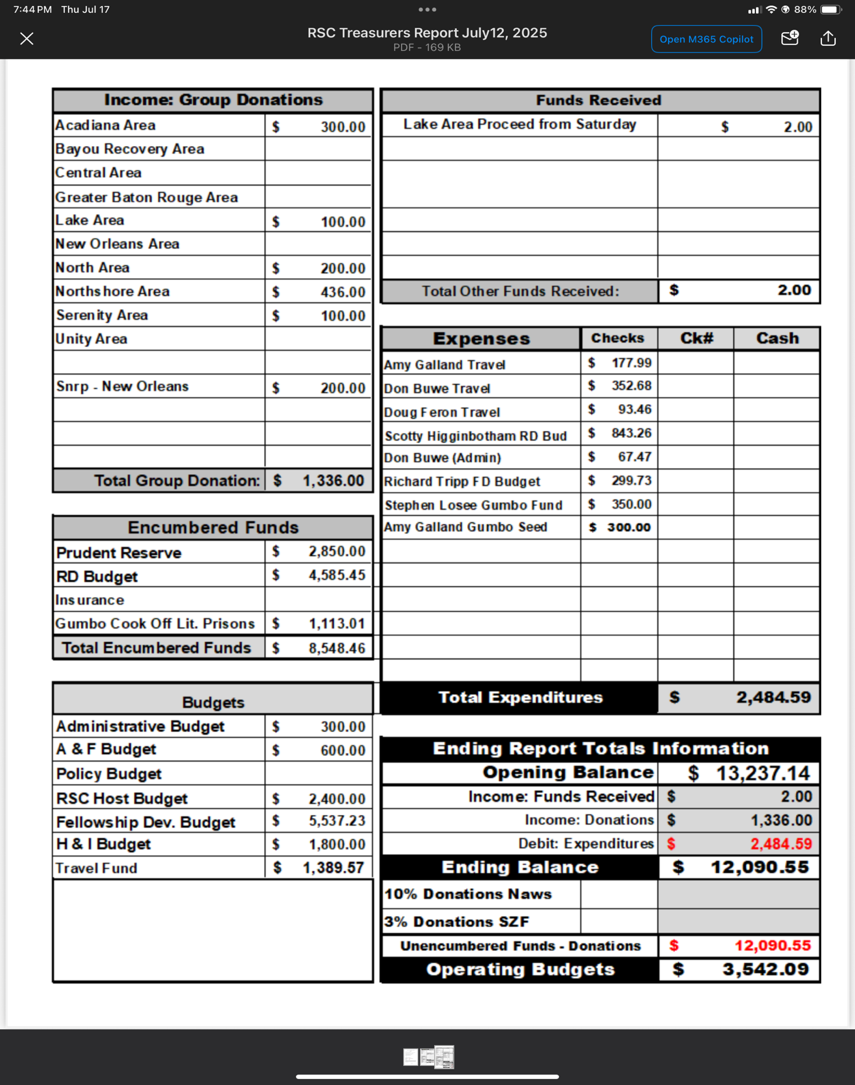

- Motion To Close Meeting:

Maker: Taylor P. Bayou Recovery Area
2nd by: Daniel S. Serenity Area

  - Closing Serenity Prayer –

  - Meeting Adjourned 2:30 pm

Minutes Prepared By: Ashley J
Acting Secretary of LRSCNA

Regional Rotation
October 4th-5th North Shore Area
January 10th-11th Acadiana Area
April 11th-12th Greater Baton Rouge Area (5th is Easter Sunday)
July 11th-12th New Orleans Area
Bayou Recovery Area
Central Area
North Area
Serenity Area
Unity Area
Lake Area

NOTE: EMERGENCY MEETING MINUTES, CONVENTION BOARD MINUTES, SERVICE RESUMES AND ORIGINAL PAPER MOTION COPIES HAVE BEEN APPENDED TO THE END OF THIS DOCUMENT

