Louisiana Regional Service Committee
of Narcotics Anonymous
Minutes - Sunday, January 12, 2025
- Meeting Convened:
  - At 10:28 AM
  - 1900 Pine St., Monroe, La
  - Hosted By Serenity Area

- Readings:
  - Serenity Prayer – Amy G.
  - 12 Traditions – Stephen L.
  - 12 Concepts – Bob St.
  - Purpose of the RSC – Taylor P.

- Roll Call
  - Administrative Committee:
    - Chairperson – Amy G Present 504-450-6839 amygunity@yahoo.com
    - Vice Chair – Vacant
    - Treasurer – Don B Present 504-234-8301 donb.larna@gmail.com
    - Secretary Vacant
    - Regional Delegate – Bob St Present 225-335-4940 bstorer79@gmail.com
    - RD Alt – Scotty H Present 337-304-3419 scottyhigginbotham@yahoo.com
    - RD Alt. Elect –
  - Standing Committees:
    - A & F – Vacant
    - H & I – Stephen L Present 337-263-3656 s.losee@yahoo.com
    - Policy – Vacant
    - Fellowship Dev– Richard T. Present 318-578-0344 nlananet1@gmail.com

  - Interested Parties:
    - Board of Directors – Ron D. Present 985-507-5685 nacaveman@yahoo.com

  - Area Service Representatives:
    - Acadiana – Absent (E)
    - Bayou Recovery – Taylor P. Present 225-337-1635 lofyt@hotmail.com
    - Central – Doug F Present 318-447-1241 dfearon56@gmail.com
    - Grtr. BR – Absent (E)
    - Lake – Stephen L Present 337-263-3656 s.losee@yahoo.com
    - New Orleans – Don B Present 504-234-8301 donb.larna@gmail.com
    - North – Ashley J. Present 402-860-3721 ajessen09@outlook.com
    - Northshore –Charles W Present 850-598-3805 combatcontrol1987@gmail.com
    - Unity – Robbie G. Present 504-427-4401 robertguillot1955@gmail.com
    - Serenity – Daniel S Present 318-245-0604 bigdaddystew1979@gmail.com

- Quorum Established:
  - Yes - 8 Areas present out of 10.

- Approval of Previous Quarterly Region Minutes:
  - October 2024
  - Motion to Approve Minutes As Typed by Ashley J. (North Area)
2nd. By Daniel S. (Serenity Area)
- Reports:

  - Administrative Committee Reports:
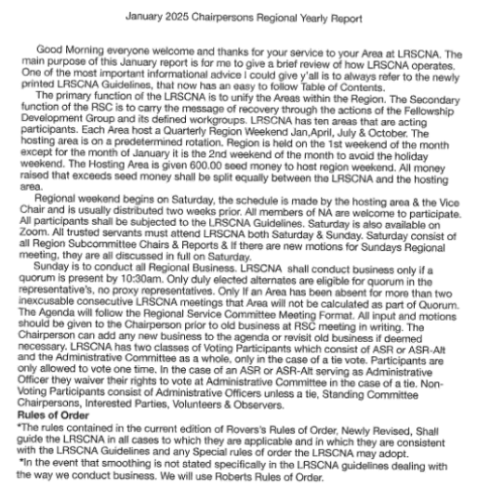
    - Chairperson – Amy G.

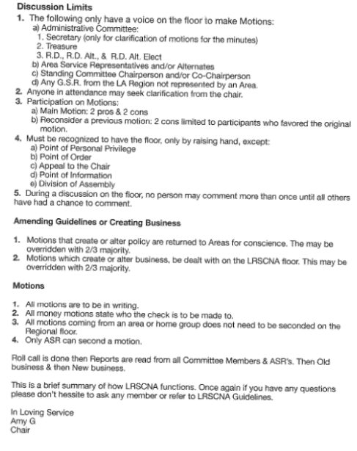

    - Vice Chairperson Report – Vacant

    - Opening Treasurer’s Report – Dob B – Report Submitted
Good morning, I am Don and I am an addict.
I notice two debits in the month of November and December for membership purchases for Canva. At that time, I called the bank and notified them that I did not authorize these purchases. Our bank immediately closed the Debit Card and reissued us a new one. Upon further investigation I noticed that the Canva membership was purchased by accident using the wrong card number that was on file. I contacted Canva and they reimbursed us for one of the charges and I will reimburse $30.00 to the Region for the other charge. This Canva membership has been cancelled, and the card information is no longer valid.
Next, The Pre-Christmas Night of Fun Committee asked to purchase liability insurance for their fundraiser. So, I contacted Vista International and purchased the policy for $128.52. The Pre-Christmas Committee did reimburse us for this amount.
Here are the following Transaction that occurred since the close of October RSC.
Debits
- 2 Transactions for Twillo - $20.16
- 3 Transactions for Digital Ocean - $26.97
- Check for Reimbursement to Don B for Post Office Box $170.00
- Payment to Vista Insurance for $128.52 for Liability Insurance for Pre-Christmas
- Check to the North Area for $100.00 to cover rent for October’ RSC
- 2 Purchase for Canva - $45.00
Credits
- Deposit of $1,050.00 Cash – Gumbo Cook Off
- Deposit of $300.00 Cash – Return of Gumbo Cook Off Seed Money
- The Pre-Christmas Committee reimbursed the Region $128.00 Cash for Liability Insurance.
- SNRP Home Group donated $300.00 cash
- The Canva Refunded $15.00

So, Our Opening Treasurer’s Report is as follows:
Opening balance $18,908.38
Debits $ 490.65
Credits $ 1,793.00
Closing Balance $20,210.73
I would also like to notify the Region that we have received our determination letter from the IRS. So, we now have documentation to prove our 501c4 status.
In February our Liability Insurance will be up for Renewal. I will be submitting a motion today to Purchase insurance for 2025. The cost of last year’s policy was $4,935.78. Motion will set a spending ceiling for 10% inflation. However, I will notify the ASR via Group Me of the new cost before renewing our policy.
There will be a couple of tasks that I will be completing between now and our next RSC meeting. I will file our annual paperwork with the Secretary of States office which will cost $15.00. I will also file our 990N Tax form with the IRS. This will bring us up to date for everything this year.
I will also work on some guidance information on how to complete these tasks along with making sure that all pertinent information such as login id’s and passwords are in the possession of the Chair as well as the Treasurer so this information can be passed on to whomever is elected to this position in the future.
In Loving Service,
Don B.

OPENING REPORT

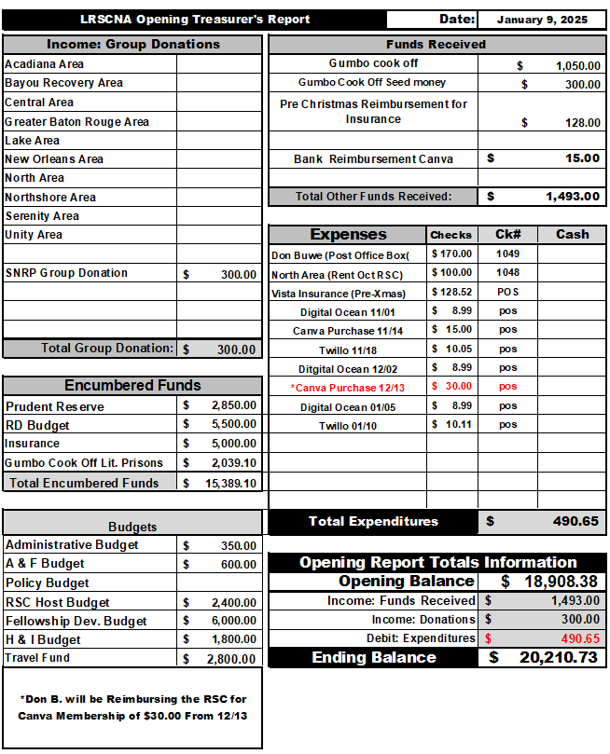

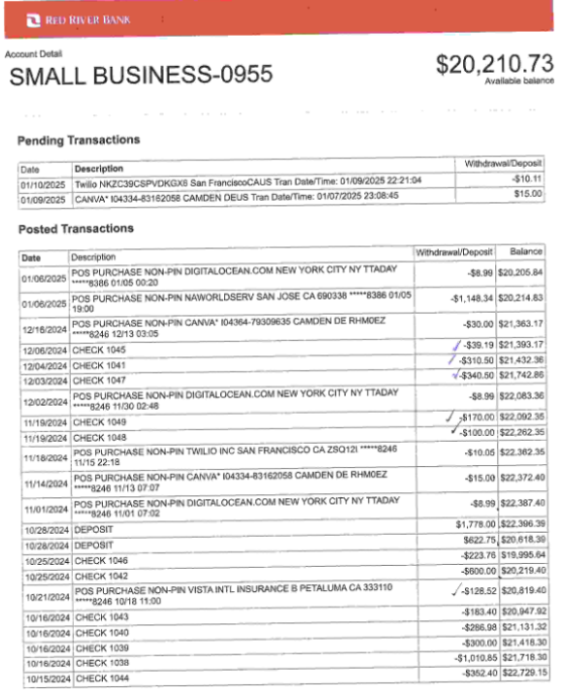

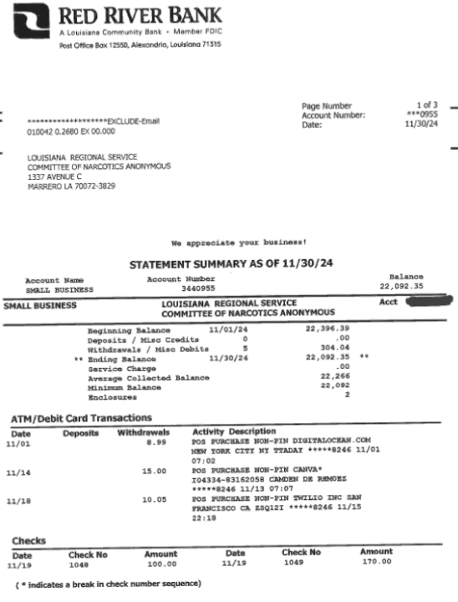

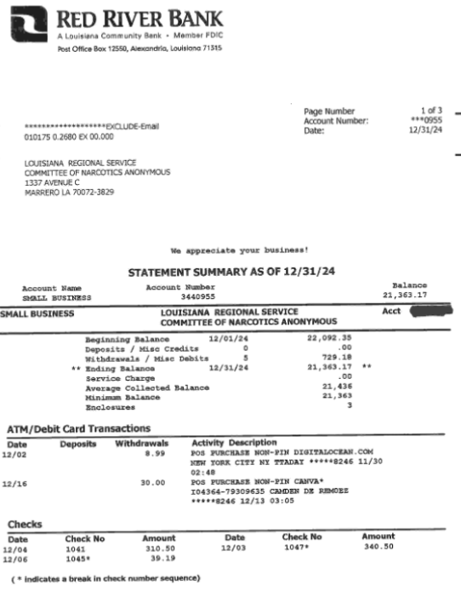

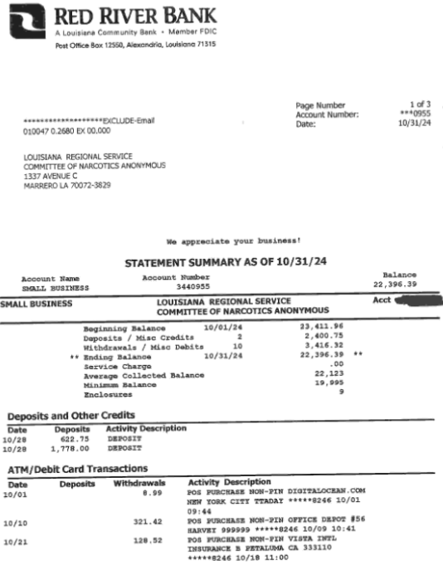

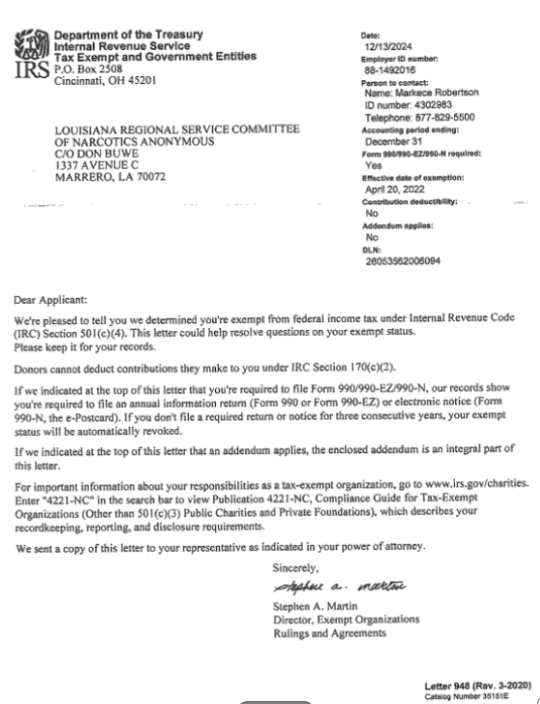

    - Secretary Report – Jax W. (Resigned)

Good afternoon. I wanted to let you know that I won’t be able to be the secretary for the region at this time. I am taking 5 classes right now in school and with that and studying for my RAC at this time I just do not have the time that would need to be dedicated to the position. I’m really sorry this is the last minute, but I have been praying about it and I just feel led at this time not to hold the position.
ILS, Jax W.
...

    - Regional Delegate Report – Bob St. – Report Submitted

Regional Delegates Report for January 2025 RSC meeting

Hello all,
There is a lot to cover but as always, if something is not clear, or you simply want to add to
what’s being said, feel free to interrupt me. Won’t hurt my feelings at all.
First, only a couple of weeks after the last RSC meeting, SZF met in Arkansas beginning on
Friday the 25th of October until Sunday the 27th at about noon. This was not the original plan. The start time was supposed to have been Friday evening. When the steering committee for SZF met that week, they decided to start at 3 pm. Given that it would take me 10 hours to get there, I
decided to drive up on Thursday instead of Friday causing the cost of my hotel to go up for one
extra night.

Friday:
Among the Regional reports, Arkansas’ RD stepped down and cited health reasons.
Lonestar has a convention coming up on Easter weekend. Lonestar also discovered
recently that some trusted servants had embezzled funds from the service office and are
having this investigated by police.
The Facilitator (Scott M), reported that they ran into problems with the bank when they
tried to change the account to align it with the EIN they obtained. The plan is to
completely change banks and the new account will be aligned with the EIN.
The Treasurer (Sharon) tendered her resignation. She cited “things going on in my life,”
and did not specifically say what those things were, but it was learned later that her
husband of many years had just died in the past several months. However, she also
commented that she was unable to keep track of the finances with the spreadsheet that
she had been told to begin using. She did say she will be glad to assist the new Treasurer,
whoever that may end up being. The balance in the SZF account was given as
$16,281.05.
The Zonal Delegate (Scott K) reported on the US Zones meeting. He was asked about the
role of the ZD since we don’t have a “seat” at WSC. In the end, the task of clarifying and
designating the role of the ZD was given over to a Guidelines Workgroup.
The Fellowship Development Comm (Kristen D) reported that their “basic text project”
for Arkansas, which focused on getting the basic text into the prisons in Arkansas, is
being dropped due to not enough people to work on it. The information they gathered so
far will be transferred to the Arkansas Region so they can pick it up if they choose to do
so. FD is also working on a “HRP Spreadsheet” for SZF.

PR (Craig G.) reported that he met with Ar folks six times to prep for a “NA for
Professionals” presentation that was held earlier that day (10/25/24). Despite their
planning and outreach, there were only 5 professionals in attendance, and 3 of them were
attending virtually. There was also some discussion about this presentation not appearing
on the SZF agenda since it is for the local Region, and not for SZF members. In fact,
apparently there have been some problems in the past with NA members attending
uninvited and not putting the most attractive image forward for NA to those
professionals.
Racism Wkgp (Alicia) Again asked about presenting/sharing information they have
gathered with US zones and others. Talked about this being the basis for a future IDT.
The wrkgp was again reminded of the tasking to come up with concrete ways for SZF to
address racism in SZF activities. This led to discussion about a wide range of ways to
address racism, most of which appeared to be proactive where the tasking is to look at
reactive measures. They will attempt to come back to next meeting with
recommendations.

Saturday:
Mentorship Wkgp (Marc) Said that FD will be developing a list of “mentors” and
assigning mentors over the next 6 months. Said that the wkgp will finalize guidelines
during this period. Talked about doing a workshop and recording it via zoom to make it
available to others on demand. He later asked for a region to volunteer to have him/them
do a trial run of the workshop being developed.
Guidelines Wkgp (Russ) Highlighted inconsistencies in the current Guidelines. His plan
is to make changes consistent with what the SZF has already agreed to. Then he will have
recommended changes for SZF to discuss and decide upon.
Workshop on Unity (Cindy B): Good workshop addressing how service bodies and
servants can work together, but not sure how it applies to SZF or why it was done.
Old Business:
1. Missouri announced they will do workshop in interim WSC report virtually and all are
welcome. Scott said he will ask to have our WB reps do it then/there.
2. RBZs for WB positions: Bob Singer’s submission forwarded by me, seconded by Russ
(Texas). We got Bob Singer on zoom to talk to SZF reps. His service resume will be
submitted and he will be voted on at next SZF meeting in January.
3. Later in the day, Cindy B. was recommended for RBZ. She agreed to be available at next
SZF meeting to answer questions.
Workshop on Reimagining &amp; Revitalizing Service (Russ and Alicia) I saw only 2
people from the local fellowship in attendance. Good workshop and worth any area
hosting. Focused on how to get new people involved. Possibly using a task group
orientation as opposed to a long-term commitment. Give activities to younger folks to get
new ideas.

Workshop on DRT/MAT (Bryan and Laurie) Asked people to look at when and how
their own qualification as a member of NA was challenged by self or by others. Again,
good workshop for a group or an area, not so much I think for a region or for zone.
Open Forum:
1. Alternative Literature: At WCNA police were called. They were told to leave the
premises... Cindy said she knew who threw the material in the trash... It was not on
convention property... Said there are multiple policies in place to deal with this right now.
Others, however, agreed that there ought to be a better way than repetitive confrontations.
2. Financial concerns WCNA: Susan: WCNA always loses money... They are looking at
other options. Marc: Always loses money in North America... Russ: Moving forward we
would look at feasibility of having it in the future... Look at all the information and make
recommendations... Ruben: We will get a rebate back from DC... Cash money hasn’t been
counted yet... sales from merchandise have not been finalized... (comments about people
not donating enough to NA). (Note: I contacted Danny G, our liaison to WB and asked if
not having a financial report to fellowship put us in violation of any filing requirements.
He stated that annual report is a “courtesy” and not one required by law).
3. Executive Director’s comments at WCNA: Cindy: There is a policy... He didn’t want to
share... They made an exception for him because his term was ending and it was his
home where he got clean
4. The PPP loan has apparently been discussed ad nauseum and I have been documents that
track the discussion on how and why the WB asked for forgiveness. I don’t necessarily
agree with their logic, but if anyone wants to know about it, I can make those documents
available to you.

Sunday
1. Budget task group recommends that SZF meets in person once per year and by zoom at
other times. Cost of meeting in person has been an average of $6000 and annual income
has been $16000, which cannot support meeting in person 3 times per year. This led to a
lot of discussion regarding the productivity and value of meeting in person v meeting
virtually. Sharon: You could try it for one year and see if it works. Cindy: Might check
with other zones and see what they’re doing. Marc: 4 days in person once per year is
what’s done by a lot of other zones. Chuck (local member): Don’t minimize the effect
you have on the local community... Can’t do that virtually. After a great deal more
discussion, we were directed to bring it back to our Regions. Next meeting, January, will
be virtual. July meeting will be in person in Texas. **Scotty will represent us at that
meeting as I will be on my way to Alaska!**
2. Budget task group recommended that budgets for next year be set at the spending level
they had last year.
3. Later, Craig asked for specific approval of his budget. Some discussion on whether this
needs to go back to RSCs? I opposed that and said this body is responsible as it is the
only group that has the knowledge of resources available and work that is needed.
Eventually it was approved.
4. Alcia proposed a new workgroup: Making service work more attractive. Questions about
what region asked for this and response was that the idea came from the workshop done
earlier... Three workgroups trying to finish tasks right now. Another might be a stretch...
More comments on our focus needing to be on serving regions... An idea to put the
tasking under FD instead of making it another workgroup... No objections
5. Budget task group: Spreadsheet for Treasure to use tracking finances... Given to
guidelines for exact language but general agreement on it.
6. Callie Garbison nominated for Treasurer. Wife of Craig, the PR guy. Clean time
requirement is 10 years, she is just shy by a few months. I motioned to waive and body
agreed. If someone else is interested and qualified, they can still be nominated, but if
nobody else comes forward, Callie G will be voted on in January meeting.
Meeting closed at 11:10 a.m.
On December 7, 2024, we had Conference Participants meeting via zoom.
Anthony, the ED for NAWS was not available and Becky gave the report. Said when WB
meets in January they will be discussing the future of WCNA. Right now the estimate is
that WCNA in DC went $800,000 in the red. She reported that 21,000 people registered
for WCNA in 2018, and they expected at least 24,000 for this WCNA. Actual
registrations numbered about 17,000. There is a survey to try and figure out why
attendance was down and what changes can be made. She talked about the membership
survey to produce a membership pamphlet and provide evidence that NA works.
Response rate was down though. Sales for NA Survival Kit have been “brisk.”
Irene: Talked about a service workshop on electronic fund flow titled “Dear Prudence.”
Asking for photos for slide shows, power points, etc. Said that faces will not be shown on
social media. Asked that people in pics have given permission for the use of those pics.
There is a “photo upload” function on the convention page of website. There is a draft
outline for workshop on Virtual Service Basics and work is progressing on revisions of IP
#21 and H&amp;I basics. Should be posted for review prior to the upcoming Interim WSC.
WB members then reviewed the upcoming proposals for the interim WSC. Said that
motions 1-5 are intended to be procedural, motions 6-9 are being presented on behalf of
the Co-facilitators, and motions 10-11 are on behalf of the HRP. 12 is from the WB.
Finally, there has been a good deal of discussion on the proposals for the upcoming Interim WSC
amongst CPs and the WB both in the webinar and on a discussion board. That content will be
part of the Interim WSC Report Workshop.

In loving service,
Bob S.

    - Regional Delegate Alternative – Scotty H
Nothing additional to Report

    - Regional Delegate Alternative Elect –

  - Standing Committee Reports:

    - Activities & Fundraisers – Vacant – Amy G
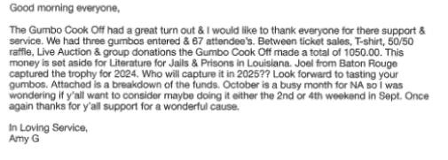

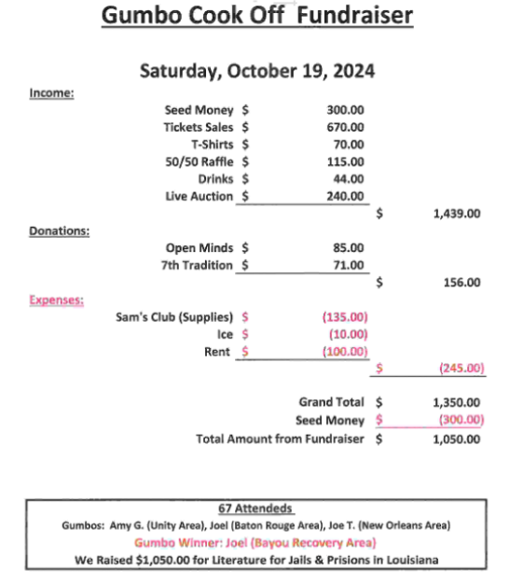

ASR please go on the LARNA.org website and list all upcoming events in your areas.

    - Hospitals & Institutions – Stephen L- Report Submitted

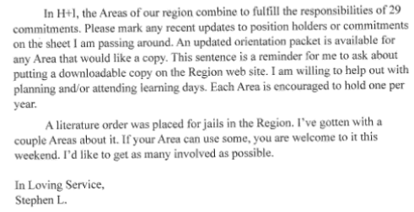

    - Fellowship Development – Richard T. – No Report Submitted

Hello all!
FD has been doing routine work. Thanks to the efforts of trusted servants in each area the
meeting database is staying current. The area websites are also in the process of being upgraded
with new backends to stay current on security and compatibility. The helpline is working
reliably but we are still waiting on the letter of determination (nonprofit) to start the process of
getting the texting worked again. Hopefully we will have this soon. We are still posting social
media PSA’s.
I was unable to schedule a FD subcommittee meeting last quarter due to illness and work
demands. I am open to suggestions about possible dates to have one this quarter and whether
we want to continue doing it on zoom or have a face-to-face meeting. If there is enough
interested we could combine a FD meeting with a workshop. Please give me your thoughts on
this.
The Serenity Area is still growing. We’ve added three new towns since last RSC and New Life here in
Monroe is growing and adding meetings (thanks Jakie & Jason!) I’d love to get some feedback
on how other areas are doing and what we as a Region can do to help.

ILS
Richard T

    - Policy – Don B
I will be updating the guidelines to reflect all the motions that was voted on this pass year.

  - Interested Parties:
    - Board of Directors – Ron D. – Report submitted. –
Greetings all,
I signed the contract for the Marriot Hotel on October 17th and Ric S. dropped off the deposit to the hotel. We met on November 10th and welcomed Pleas C. to the broad. We voted not to renew the BOD mailbox. Ric filed the paperwork for the Sec of State with all the new positions of the BOD members. Pixie is working on the convention website with Steve and you can register online and please book your hotel rooms sooner than later. Denise is talking with the Marriot in New Orleans for the 2026 Convention. This year’s Convention Committee asked the board to look into Printify to create an online store to sell merchandise. After looking at the terms of agreement, the Board decided it was not advisable. The 2025 Convention is on track, but they are still looking for a Secretary and an Arts and Graphics chair, but the committee is moving forward and handling it well. Pre-Christmas Night of Fun brought a profit of $3,410. Our next Board meeting is February 15th at 2:00pm at Grace Baptist or on Zoom
BOD Minutes and Convention Minutes will be sent out in Separate email.
ILS,
Ron D - Chair

  - Area Service Representatives Reports:

    - Acadiana Area – Absent

    - Bayou Recovery Area – Taylor P – Report Submitted

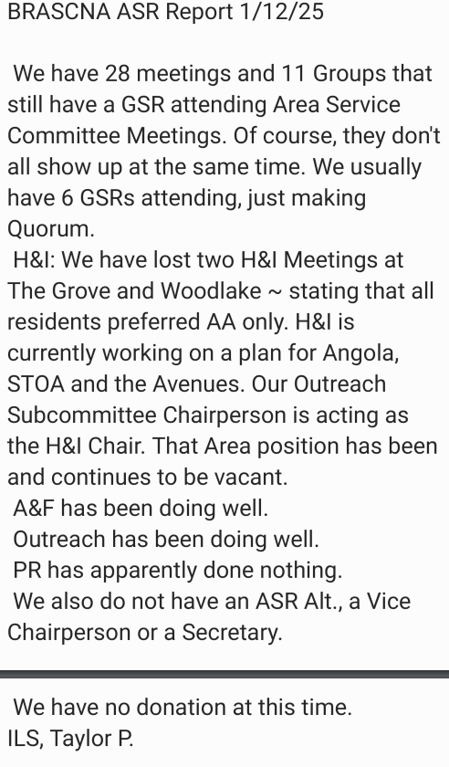

    - Central Area – Report Submitted
My name is Doug and I'm an addict. We have meetings just about every day at two Clubhouses. Attendance is low at all meetings. We voted against the motion that was sent back to areas. We have four H&I meetings at three treatment centers. I was unable to get a conscience on you all’s so called emergency motion. I'm glad to be in Monroe and to see this area growing.

MORE WILL BE REVEALED
DOUG F

    - Greater Baton Rouge Area – Absent

    - Lake Area – Stephen L. – Report Submitted
The Lake Area currently has 4 groups that combine to hold 35 meetings per
week. All 4 groups hold speaker meetings and birthdays regularly. Spirit of
the Bayou changed locations in December and are doing well in their new
building. Our Area schedule is up to date online. In H+I, we have 4 commitments:
Sanctuary every Wednesday, Pathways every Sunday, women at CCC on Tuesdays
and men at CCC on Thursdays. In upcoming events, The 28th annual Meditation
Retreat will take place January 31st – February 2nd at North Toledo Bend state park.
The former Shipwreck group started the event, and The Recovery group has/is
doing an amazing job of carrying it on to a new generation. The flyer is on the
Region web site, and I have copies to give each Area. The 25th annual Unity
Campout will take place on March 21st-23rd at Methodist Landing state park in
Leesville. Information and flyers will be distributed as details develop. Our 7th
Tradition is $100.
In Loving Service,
Stephen L.

    - New Orleans Area – Don B. – Report Submitted

Hi, my name is Don, and I am an addict.

In November New Orleans Area elected me to serve as the Acting ASR – Alt until they
can fill the position. I supplied a copy of the motion to the Region Chair

I also have a group conscience on the motion that was sent back to Area.

New Orleans Area Convention if doing well and moving right along. The convention will
be held at the Hyatt Riverside hotel on July 24th through the 27th . The deadline for Pre-
Registration is April 1st only $25.00. You can register or purchase tickets online at
NOACNA.com

Our next Fundraiser coming up for NOACNA the Mardi Gras Ball on Saturday Jan 18th
6pm to 10pm at Fellowship Hall 583 Broadway St. New Orleans. I have tickets if
anyone is interested in purchasing one. $20 pre-sale or $25 at the door.

We have a new H&I Chair, Sabrina A. and we are currently servicing 6 - H & I
commitments. We are in need for more female panel members.

We have meetings 7 days a week with a total of 42 in-person meetings, 2 hybrids
meetings and 30 Virtual meetings.

New Orleans Area will be donating $648.08.

In Loving Service
Don B.

    - North Area – Ashley J.– Report Submitted
Hello Family,

North Area is doing great at this time. For the first time in the last 5 years our area policy is up to date. There are currently 5 home groups in the North Area with 10 meetings a week with 30-40 addicts in attendance and growing steadily. H&l is going very well with Panels going into CADA on Tuesdays at 7 pm, Sundays at 545 pm and Uprising Addiction Center every other Saturday at 3:00 pm. We will be having a Valentine's Day function date and time TBA.

ILS,
Ashley J

    - Northshore Area – Charles W – Report Submitted

My name is Charles W. and I am an Addict.

The Northshore Area is doing well and growing. We have 12 home groups and 31 meetings per week. Our newest group is the New Life Group in Bay St. Louis, MS. It meets on Mondays and Wednesdays.

We actively support 2 H&I meetings
- Townsend Treatment Center in Covington meets on Tuesdays.
- Fontainebleau Treatment Center in Mandeville meets on Thursdays.

Still trying to support a third H&I meeting at the Amite Jail, waiting on a response from the Sheriff.

We are doing a PR presentation on January 22nd in Slidell.
Still Working on Convention Fundraiser. Typically, we have a Mardi Gras Ball, yet we don’t have a location. We plan on doing something even if its not the Ball.

Our Donation is from October and December for $742.07.

In caring service,
Charles W.

    - Serenity Area – Daniel S- Report Submitted
Dear family, the Serenity Area has experienced some growth since the last Regional meeting. We have added a home group in Bradley Arkansas, Magnolia Arkansas, and Haynesville, Louisiana.
The Monroe group has expanded it’s meeting offerings also. The Monroe group opened a
The new meeting at the 1900 club is on Thursday nights that began the first week of December. They have since added a Tuesday night at that location and have at least 40 in attendance. Information about the new meetings and it changes to current meetings are updated on the website. We have other home groups that have experienced no growth and some that have experienced a decline in membership.
Our area voted to match the funds obtained from Region H&I for literature racks and IP’s for treatment centers that we are trying to currently have a presence in. We have received that order and are in discussion on where to place those literature racks. Our area appreciates the initial investment from Region into our Area and we plan to replenish the literature as needed on our own regularly in hopes to further the growth of Narcotics Anonymous in our Area. Thank you all for the help.
In loving service
Daniel S

    - Unity Area – Robbie G. – Report Submitted

We presently serve 15 groups, with a total of 19 meetings and 1 zoom meeting.

Our Area Service Committee has four active subcommittees.
    - Activities & Fundraising
    - H&I – facilitates two meetings
      - Grace House – twice monthly
      - Avenues – four times monthly
    - Literature – orders & distributes NA literature. Comprised of Chair and Vice Chairperson
    - Public Information – answers helpline. Updates, publishes and distributes meeting schedules. Our public information committee also updates a website and maintains a facebook page.

In Loving Service,
Robbie G.

- Old Business:
    - Motion #2024-10-02 - Policy Change - 2/3 Majority
Maker – Taylor P. – Bayou Recovery Area
2nd – Motion Came from an Area

Motion: Policy Change – Area have voting rights when they join the RSC. The Area can be removed from Quorum Count due to absences but never lose their voting rights.
Intent: This will keep the RSC responsible for those they serve.

Vote: For 6 Against 2 Abstention 0
Motion Passed

- New Business:
  - WSC Motions: Please take all motions and the one amendment back to your Areas for a group Conscience. All votes will be forwarded to Bob St. (RD) or Scotty H. (RD Alt.) by the specified dates listed.

Amendment - Due Feb. 12th
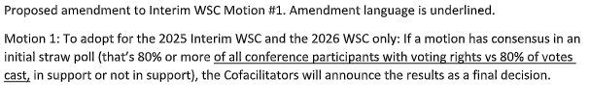

The Following 12 Motions are Due by February 20th.
Motion 1 To adopt for the 2025 Interim WSC and the 2026 WSC only: If a motion has consensus in an initial straw poll (that’s 80% or more in support or not in support), the Cofacilitators will announce the results as a final decision.

Motion 2 To approve the 2023 World Service Conference minutes.

Motion 3 To approve the 2025–2026 Narcotics Anonymous World Services, Inc. Budget. (See Addendum A)

Motion 4 To extend the 2023–2025 Reimbursement Policy through the 2026 fiscal year.

Motion 5 To adopt for the current conference cycle only: The 2026 WSC will take a new step in Strategic Planning by using a revised process (described below) for the CAR survey to consider ideas for recovery literature, service material, and Issue Discussion Topics. Instead of submitting motions for project plans to create specific pieces of service material, recovery literature or IDTs for the 2026 Conference Agenda Report, conference participants will submit those ideas for possible inclusion in the 2026 CAR survey.

Motion 6 To update A Guide to World Services in NA (GWSNA) amendment deadline policy to include first draft due forty-five (45) days in advance of WSC and final amendment deadline thirty (30) days in advance of WSC.

Motion 7 To add to GWSNA amendment deadline policy to include first draft due thirty (30) days in advance of interim WSC and final amendment deadline fifteen (15) days in advance of interim WSC.
Motion 8 To add the following language defining amendments to the CAR &amp; CAT-related paragraphs in GWSNA (pages 13 &amp; 14): An amendment to a motion is a change or addition designed to improve the motion. The purpose of an amendment is to refine a motion to move the Fellowship closer toward consensus. An amendment should clarify, add, or subtract language that keeps the motion consistent with its intent. An amendment shall not replace a motion or introduce a substitute or contrary motion. A motion to split or divide a motion is an amendment to the motion.

Motion 9 To make the following changes regarding amendments and replacements of motions during the decision-making process to Addendum D (page 67) in GWSNA: 8. The Conference may decide to replace or amend motions that have been presented based on prior discussions. When the motion is presented, the WSC Co-facilitator may recognize any participant offering a replacement or amendment or offer a suggestion to the Conference during the discussion of a motion. If supported by two-thirds of the Conference, the replacement/amendment will be accepted. The WSC Co-facilitator may interrupt this simplified process at any time they believe such action is warranted.

Motion 10 All candidates for World Service positions are forwarded to the HRP from regions, zonal
forums, or the World Board (RBZ).

Motion 11 If Motion 10 is adopted, to redefine the purpose of the World Pool to be used to retain information on candidates forwarded for consideration by regions, zones, and the World Board as a part of the Huma n Resource Panel’s nomination process.

Motion 12 To not utilize a seating workgroup for the 2023–2026 cycle

  - Motions:
    - Motion #2025-01-01 Majority
Maker – Bob St. (RD)
2nd – Stephen L (Lake Area)

Motion: RD & RD Alt are authorized to vote in accordance with LA Region’s position/conscience when known and in accordance with what they agree is right when it is not known.
Intent: Clarify responsibility of RD team @ WSC.

Call to Vote: For: 8 Against: 0 Abstentions: 0
Motion Passed

    - Motion #2025-01-02 - Majority
Maker – Robbie G. – (Unity Area)
2nd – Don B. (New Orleans Area)

Motion: To purchase a television for RSC Zoom meeting from Walmart costs $113.73. Receipt and Television Serial Number Below.
Intent: To be able to hold zoom meetings on Saturdays.

Call to Vote: For: 8 Against: 0 Abstentions: 0
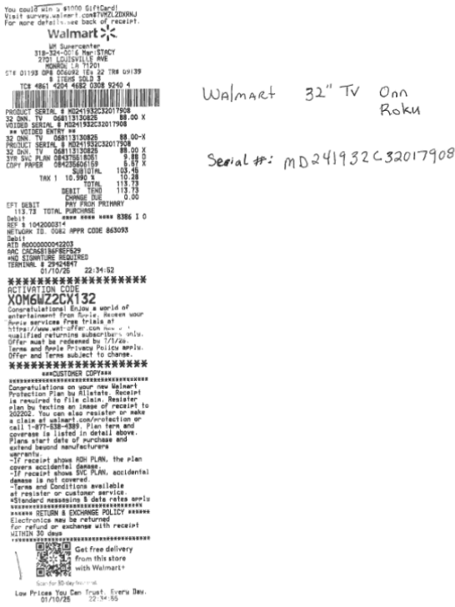
Motion Passed

    - Motion #2024-10-03 Majority
Maker – Richard T. – (FD Chair)
2nd – Daniel S. (Serenity Area)

Motion: Reimbursement for Facebook for Last quarter of 2024. Amount of $749.09.
Intent: To further carry the message

Call to Vote: For: 8 Against: 0 Abstentions: 0
Motion Passed

    - Motion #2025-01-04 – 2/3 Majority
Maker – Stephen L. (Lake Area)
2nd – Don B. (New Orleans Area)

Motion: To include “Willingness to train incoming position holder.” To the duties for each Regional Service Position. Would take effect for all 2026 nominations/elections.
Intent: To ease transition from outgoing to incoming position holders and encourage the spirit of rotation.
Override Vote: For: 7 Against: 1 Abstentions: 0
Motion Passed

Call to Vote: For: 6 Against: 2 Abstentions: 0
Motion Passed

    - Motion #2025-01-05 Majority
Maker – Bob St. – (RD)
2nd – Taylor P. – (Bayou Recovery Area)

Motion: To admend WSC motion #1 to read “80% or more of all Conference Participants with voting rights (vs votes cast) in support or not in support”
Intent: Get Literature into treatment centers.

Referred Back to Areas

    - Motion #2025-01-06 Majority
Maker – Don B. – (Treasurer)
2nd – Daniel S. (Serenity Area)

Motion: To purchase Liability Insurance for 2025. Approved to have a 10% increase to last years price.
Intent: To fulfill guideline requirements.

Call to Vote: For: 7 Against: 0 Abstentions: 1
Motion Passed

    - Motion #2025-01-07 Majority
Maker – Stephen L. – (H&I Chair)
2nd – Don B. – (New Orleans Area)

Motion: To reimburse H&I for a Jail/institution literature order. (Gumbo Cook Off Funds) Make Check Payable to Stephen L. $576.27
Intent: To distribute Literature to Jails/Institutions in our Region.

Call to Vote: For: 8 Against: 0 Abstentions: 0
Motion Passed

  - Host Area For January 2025 RSC: Serenity Area
Serenity Area returned receipts and $144.00 from the $600.00 seed Money. The Saturday function had a great turnout with a large crowd of attendees. This was great for FD outreach for this Area.

  - Host Area for January RSC:
Next Region will be held in the Unity Area on April 5th and 6th 2025. A check was issued for seed money in the Amount of $600.00

- Treasurer’s Report – Don B. - Closing Treasury Report
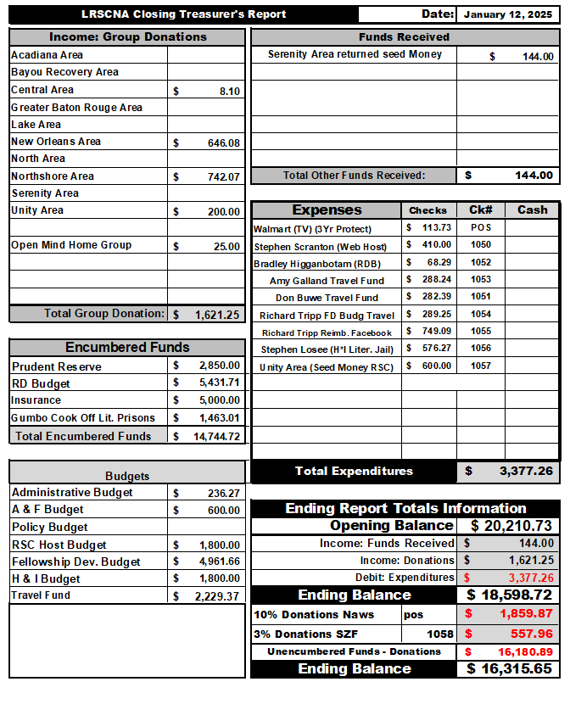

- Motion To Close Meeting: Maker: Daniel S. (Serenity) 2nd by Don B. (New Orleans Area)
  - Closing Serenity Prayer – Amy G.

  - Meeting Adjourned

Minutes Prepared By: Don B.
Acting Secretary

Regional Rotation
April 5th – 6th Unity Area
July 12th – 13th Lake Area
Oct. 4th – 5th Northshore Area
Acadiana Area
Greater Baton Rouge
New Orleans Area
Bayou Recovery
Central Area
North Area

